Muscles
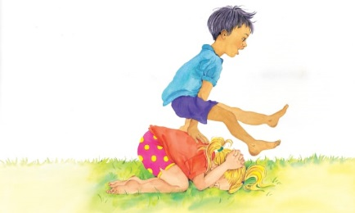 | Strong muscles under your skin help you ________ and __________ your body. You use muscles every time you shake your head, wiggle your toe, or _________ up and down. These children are playing leapfrog. This game uses lots of ______________!
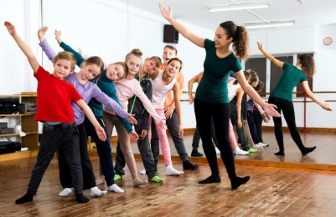 | Dancing is a really fun way to ______________. Everybody has a good time moving their arms and ________ to music!
 | With lots of practice, your body can do amazing things. This girl can jump up high and _________ her legs wide apart.
 | Exercise makes your muscles _______________. Your body has more than ________ muscles!
What are some of your favourite ways to exercise? | _______________________________________  _______________________________________  _______________________________________

