Monkey
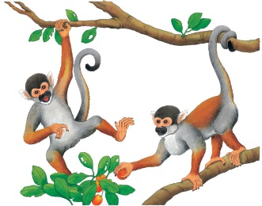 | Monkeys live in groups in the ________. They are amazing acrobats that leap from branch to branch and ___________ from the dangling vines. When monkeys play, they ___________ and whoop loudly. What a racket!
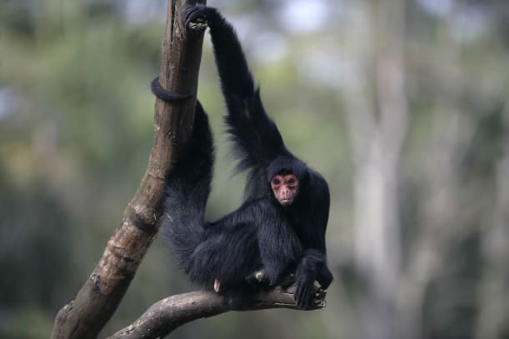 | A monkey holds onto the branches with its strong ________. Long arms and legs help them ___________, leap, and run.
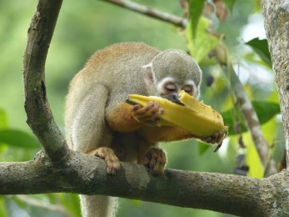 | Monkeys have ___________ and toes. They use them for grasping things, like _______________ or tree branches.
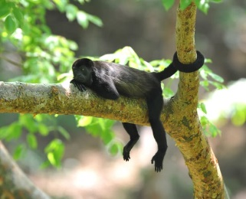 | A monkey has a long ________. The monkey curls its tail tightly around a tree branch to help keep its ______________________.
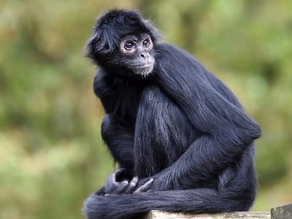 | Monkeys have large ________ that face forward. Big eyes help a monkey spot danger and stay _________.
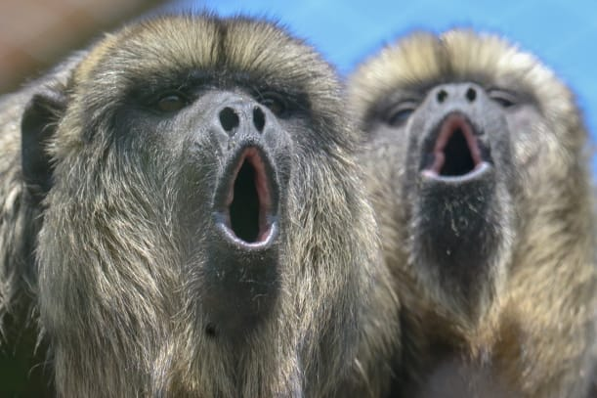 | Monkeys chat and squabble with each other. They also make funny __________.

