Medical Professionals
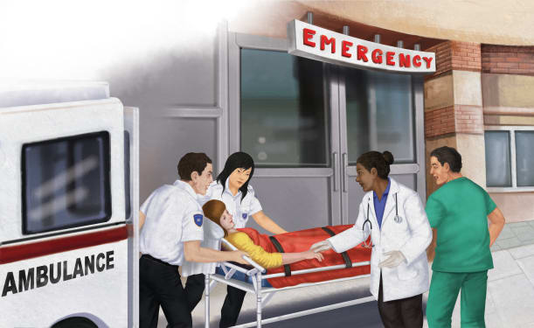 | Doctors, ___________, and other medical workers take care of ________ or injured people. Special ____________________ ride in ambulances. They take care of people who have been in an _____________ or who suddenly become ill. The paramedics shown here are bringing a patient to a ____________.
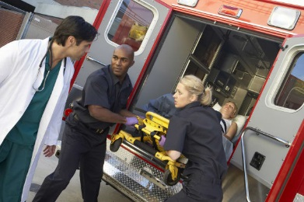 | Paramedics drive an __________________. The ambulance carries injured people to the ____________. _____________ take over the care of the patient at the hospital.
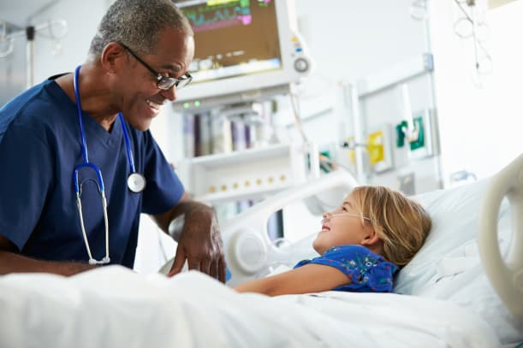 | A ___________ helps care for a patient.
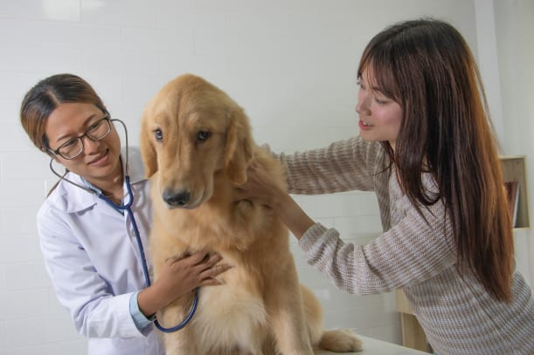 | _______________________ are doctors who take care of ____________. She uses a ______________ to listen to sounds made by a dog’s __________.
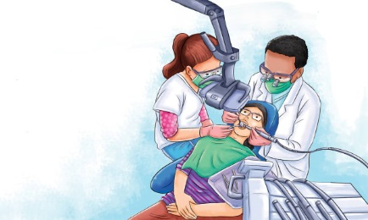 | A ____________ is a doctor who helps us take care of our __________. Dentists clean teeth and _________. They check for ___________ in teeth. They fill in the cavities to save the teeth and keep the ____________ from hurting. Dentists also take out _______ teeth. Dentists teach people how to _______ for their own teeth and gums
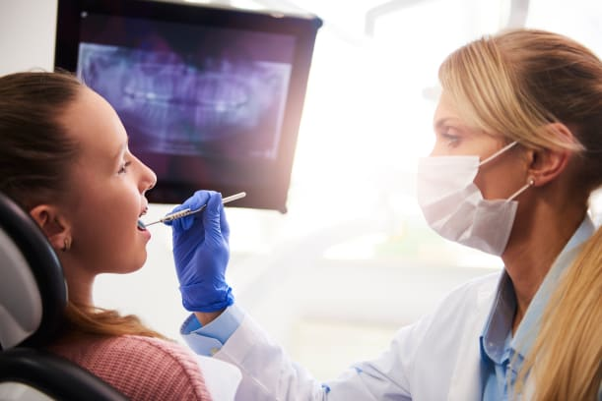 | An ______________________ is a special kind of dentist. Orthodontists put in _________ to straighten crooked teeth. Dentists and orthodontists wear a __________ so that they do not breathe __________ on the patient. Gloves protect against the spread of germs. A ___________ helps to see all sides of the teeth.

