Lawmakers and Lawyers
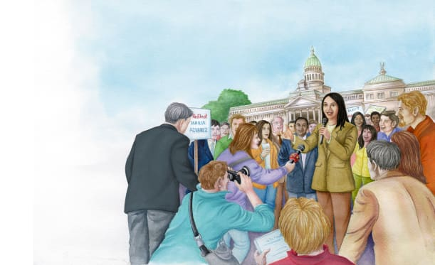 | A lawmaker is a person who makes ________. Laws are ________ that people must follow. Lawmakers represent the people of the community. They work to _____________ the people. Lawmakers must run for office. People in the community __________ to elect their lawmakers.
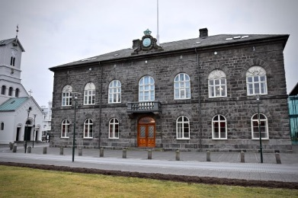 | The Althing of _______________ is the world’s oldest lawmaking group. It was formed more than ____________ years ago!
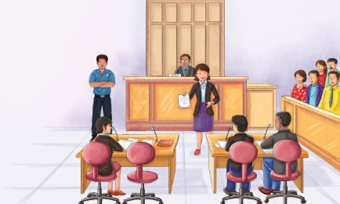 | A ____________, or solicitor, is a person who tells people what the laws are and helps people use the laws. Some lawyers try to help people who may have ___________ a law. Other lawyers try to show that someone did break a law. And other lawyers ________ papers to help people do business with each other or take care of what they own.
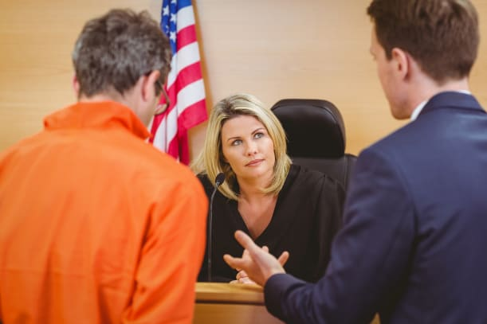 | People go to ____________ to settle disputes or when they are accused of breaking the law. A lawyer speaks in a ________________ (room for trials). A lawyer presents his client’s __________. A lawyer’s client may be a person or a ________________. A _____________ is charge of the court. Judges are people who work in courts of law.
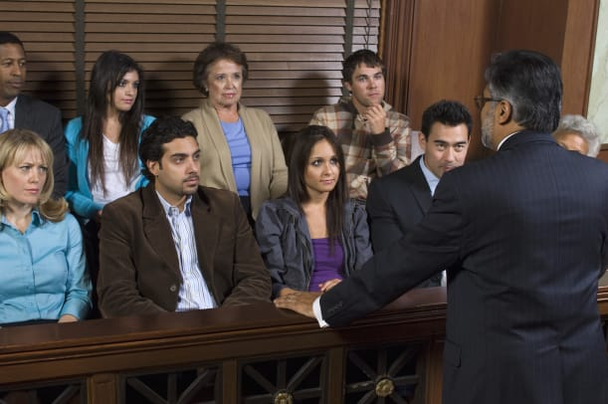 | A group of people called ____________ listens to the case.

