Jaguar
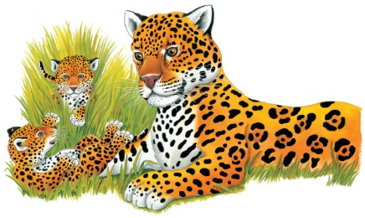 | The jaguar is the biggest and most powerful ______ in the rain forest. It can climb trees and _________. At night, the jaguar prowls the forest floor __________. Then it lies in wait for animals to eat. During the day, it relaxes in a ________ or a patch of grass.
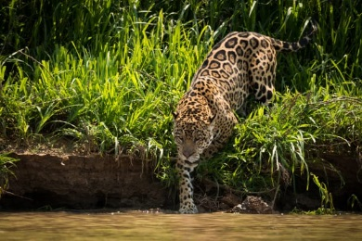 | A jaguar has golden ______ and many _________. A spotted coat makes a jaguar hard to _______ in the shady grass and trees.
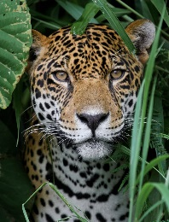 | Long ______________ help a jaguar feel its way through the thick grass. Jaguars _________ mainly on the ground at night.
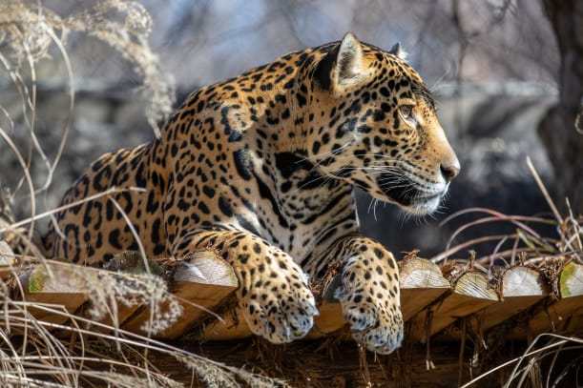 | Soft padded ______ hide a jaguar’s sharp claws. Jaguars use their __________ for gripping prey and climbing trees.
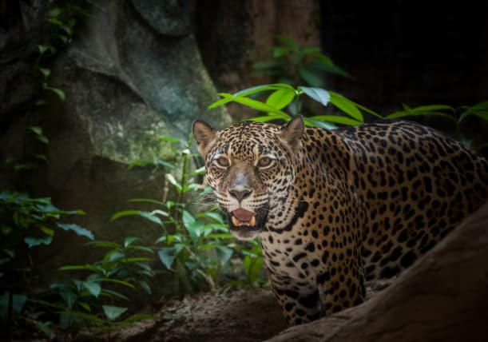 | A jaguar is a fierce ____________. When hungry, it creeps up on an animal. Suddenly, it _____________ before the animal can escape.
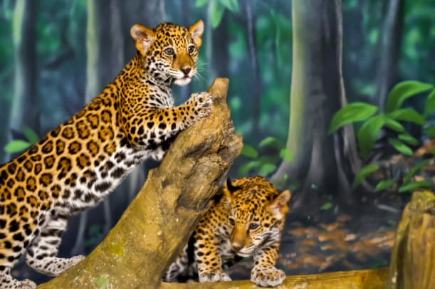 | Jaguar ________ like to play. It is a fun way to ________ how to fight and hunt.

