Inside My Body
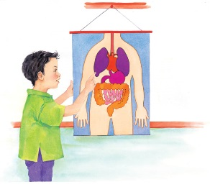 | Your body is packed full of soft parts, called _________, that do important jobs. They help you to _____________, to eat, and even think. There’s also a lot of thick __________ inside your body. It carries food and _____________ around, from your head to your toes!
 | When you ___________ out underwater, you can see the air come out of your mouth and nose in lots of _________________.
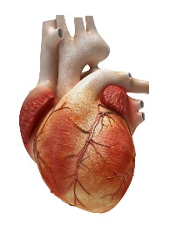 | Your __________ pumps blood around your body all day and night. The heart beats about _____ times per minute without rest for your whole lifetime!
 | Doctors use a special instrument called a _______________________ to listen to your heartbeat. Your heart sounds like a drum. Thump! Thump!
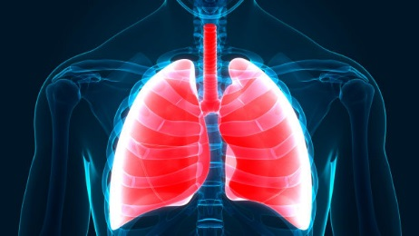 | Every time you breathe in, two spongy bags called __________ fill up with air.
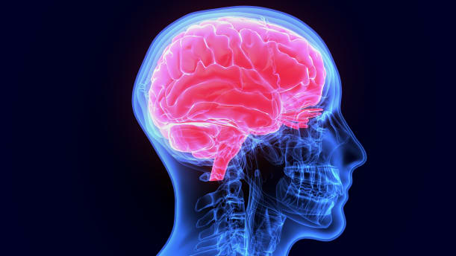 | Your ___________ is inside your head. It help you to think and __________.

