Insects and Spiders
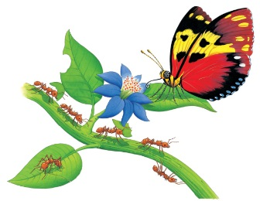 | There are more insects in the rain forest than any other animal. An insect has _______ legs and _________ main body parts to its body, which has a tough covering. A spider has _________ legs. It has __________ and can spin silk. Spiders feed mostly on insects.
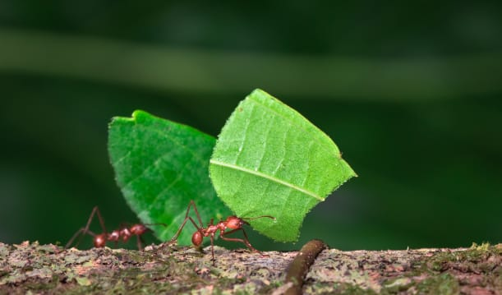 | Leafcutter ________ cut pieces of leaves from trees, shrubs, and other plants. They carry the leaf parts back to their ________ to make food.
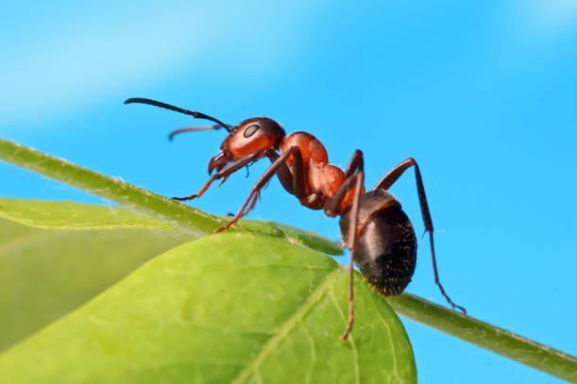 | An ant’s body has __________ sections and six legs. A hard case protects the ________ like a tough coat of ___________.
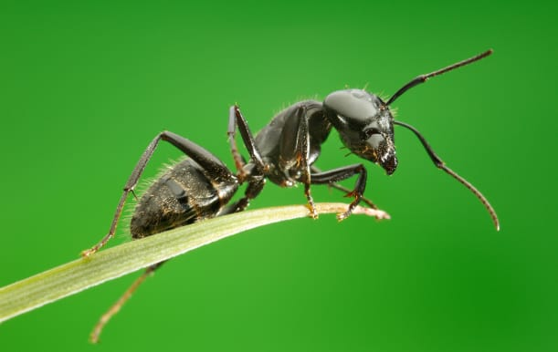 | An ant smells, tastes, and touches the world around it with long _____________ on top of its _________. Most insects have feelers.
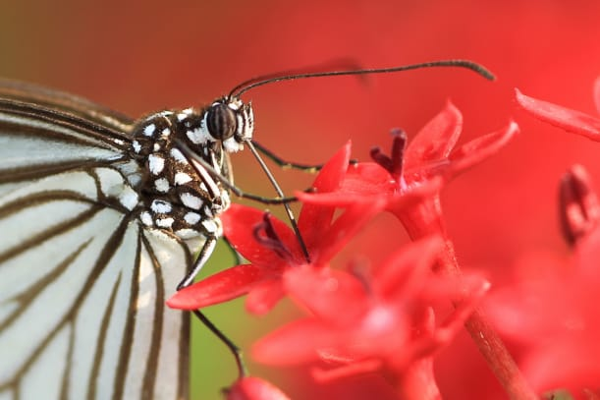 | A butterfly’s _______________ is a long hollow tube. It sucks up juice from flowers like a ________.
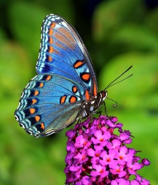 | A butterfly is among the most _________________ of all insects. Most butterflies have ________ with beautiful patterns.

