House-to-House Workers
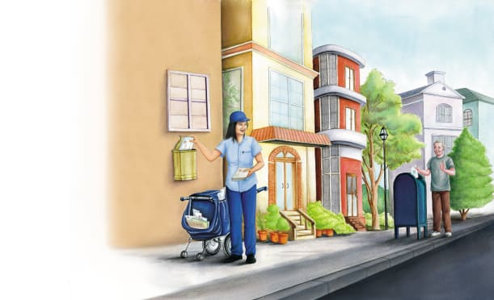 | Mail carriers help people in a community send and receive letters and _______________. Many workers handle _________ as it travels from place to place. Mail carriers collect mailed letters from a ___________. They also deliver mail to homes and businesses.
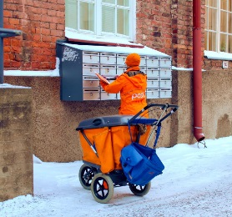 | Mail carriers work in all types of ________________, A mail carrier wears a special _________________. Some mail carriers use a cart to carry mail. People place __________ in a post box. A mail carrier collects these letters.
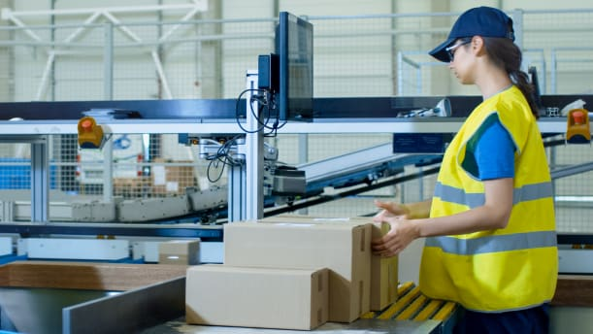 | Postal workers sort and process _________ at a post office.
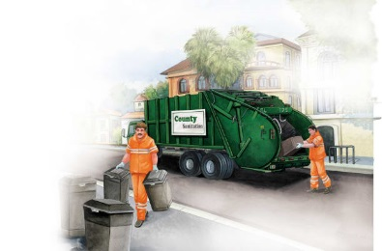 | Garbage collectors help keep the community ____________. They pick up garbage from homes and _____________________. Other workers also keep the community clean. They may ___________ or hose down streets.
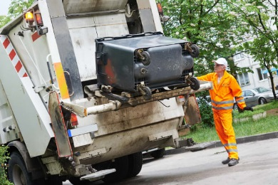 | The garbage collector empties the garbage into the truck’s _____________.
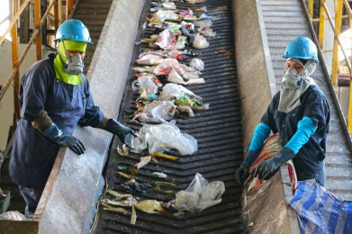 | A garbage truck takes _____________ to a dump or recycling centre. Workers at recycling centres sort and break down old paper, ____________, metal and glass items. These materials are then used to make _______ items.

