Helicopter
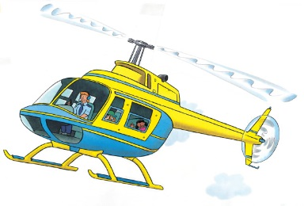 | Have you ever seen a __________________ whirling in the sky? It can fly straight up and down and even ___________. Helicopters have many jobs. Some people watch the __________ below, others take people sightseeing!
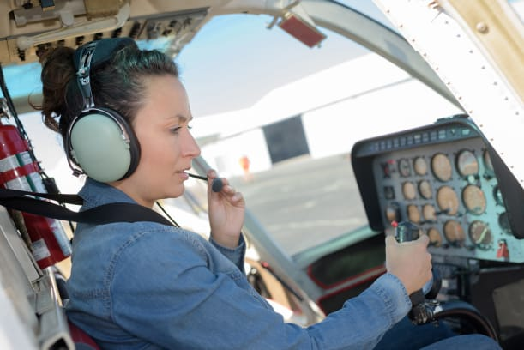 | A ___________ sits at the front and flies the helicopter. A headset lets the pilot talk to people on the ground. The pilot moves a ______ ________ to make the helicopter go up and down or stay still.
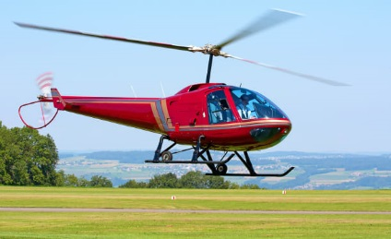 | Flat ___________ whirl around and lift the helicopter into the air. A long ________ with spinning blades at the end keeps the helicopter steady.
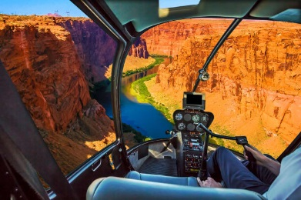 | Passengers sit behind the pilot in the bubble-shaped ___________ and look at the amazing view.
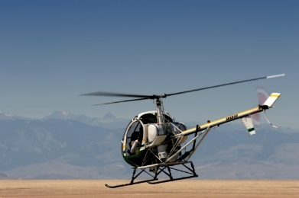 | The helicopter lands gently on its two strong ___________.
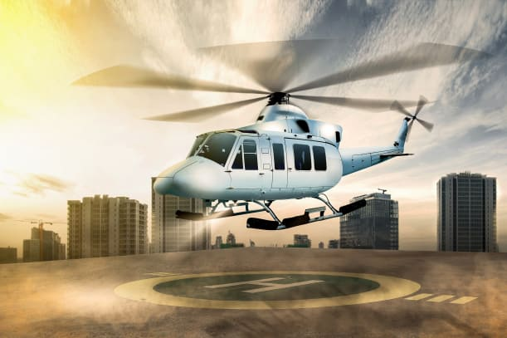 | A helicopter can ________ in a small space. It can even squeeze onto the top of a high building in a busy city. It lands on a special platform called a ______________.

