Garbage Truck
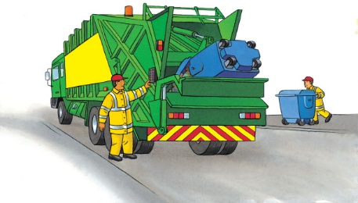 | When you throw something away, it ends up in a garbage can, dumpster, or ________________ bin outside. A collector empties the garbage container into a __________. The truck takes the garbage to a __________ or recycling centre.
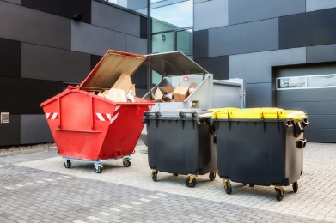 | A _____________ is large enough to hold all kinds of rubbish.
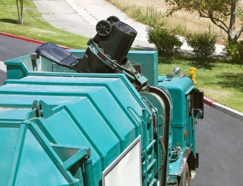 | A lifting _______ picks up the heavy dumpster and empties it into the truck.
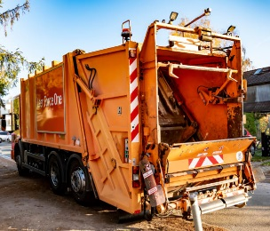 | Inside, a ________________ squashes the garbage. Now there is room for even more. The compactor pushes the garbage deep into the _____________.
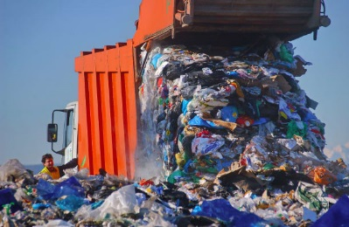 | At the ________, a garbage truck empties its load. The back of the truck ________ up, and all the garbage tumbles out.
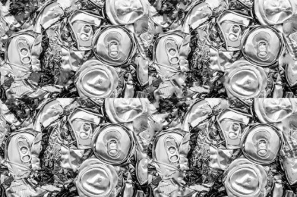 | Some garbage can be used again and again. This is called ________________. Old cans can be recycled into new ______!

