Frog
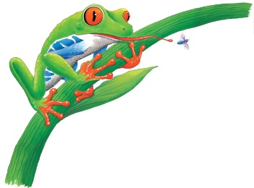 | All kinds of brightly coloured frogs ________ around the steamy forest floor. They splash in __________ and make their homes in puddles left by the rain. The _____-_______ tree frog in the big picture is an expert at ________________ trees.
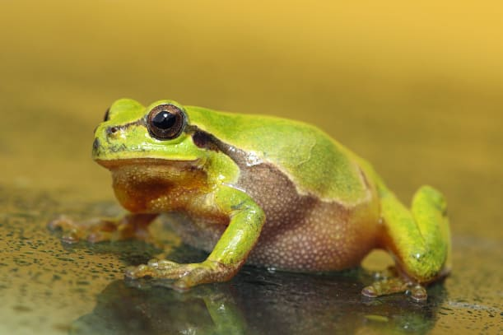 | A frog breathes through its slimy _________. It also breathes through its _________.
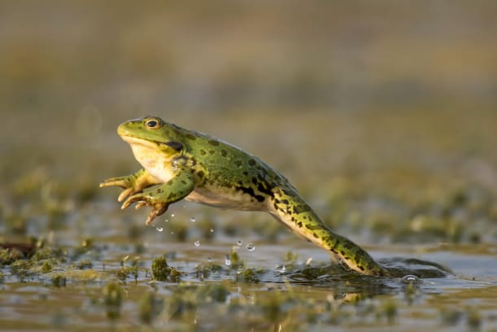 | Strong back ________ help a frog hop after ___________ for food. Their legs also help them ________ away from enemies.
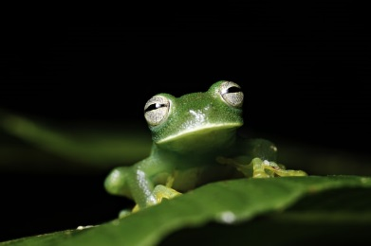 | A frog’s big ________ bulge out of the top of its head. These bulging eyes help it to see in almost all __________________. It can quickly spot ____________ buzzing past.
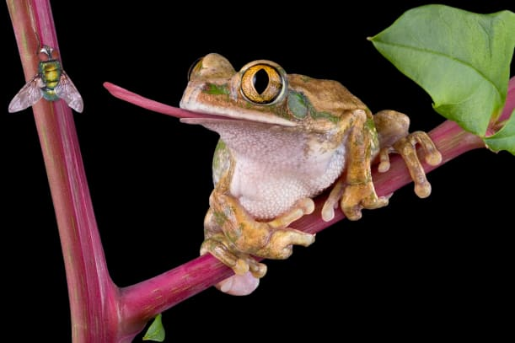 | A frog flicks out its sticky _______________ to catch a passing fly.
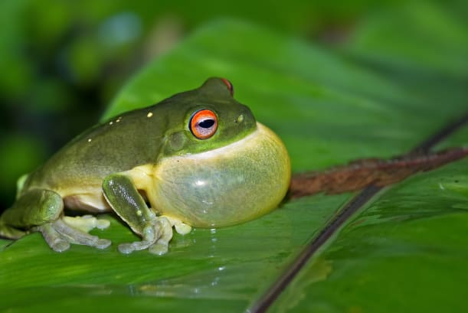 | When a frog calls out to other frogs, it puffs out its ________ like a balloon. This makes a loud _____________ noise.

