Food from Trees
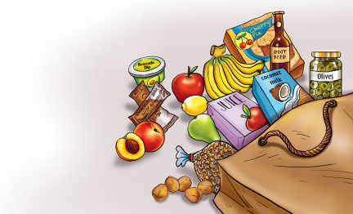 | Many of the foods we eat grow on trees. Apples, _______________, oranges, coconuts, and other fruits grow on trees. Other kinds of trees grow ________________, pecans, and almonds. Coffee and ____________ are made from __________ of trees.
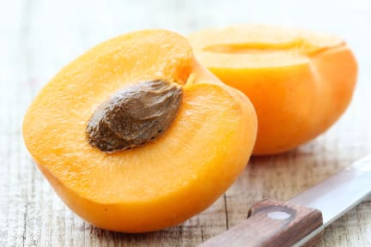 | Many delicious kinds of fruit grow on trees. The fruit from some trees have a hard ____________ inside called a pit or _____________.
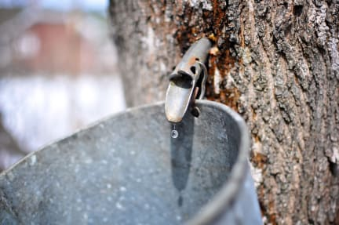 | Trees contain a sugary juice called ________. The sap of the ____________ tree is used to make maple syrup.
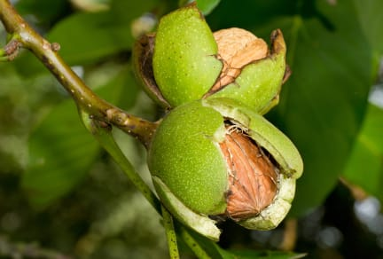 | Many kinds of ________, such as walnuts, pecans, and almonds, grow on trees. Nuts grow in a woody ___________.
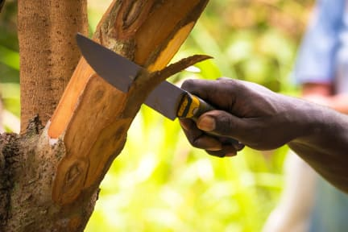 | ___________________ is made from the __________ of a tree. It is popular spice used in cooking.

