Fire Engine
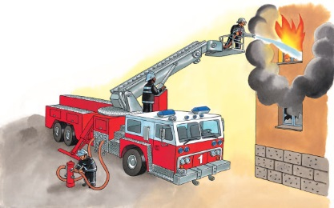 | At the fire ____________, a loud alarm bell sounds! In minutes, a shiny red fire ___________ and its crew arrive at the fire. On board the engine is a ________. The firefighters use it spray _________ to put out the fire.
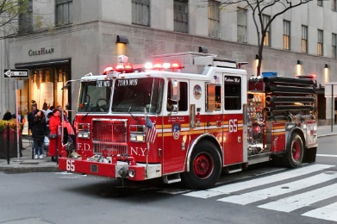 | Flashing lights and a loud _________ warn people to stay out of the way.
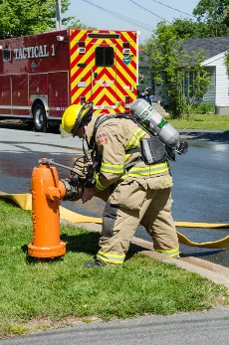 | A long house carries water from a fire ______________ to the fire.
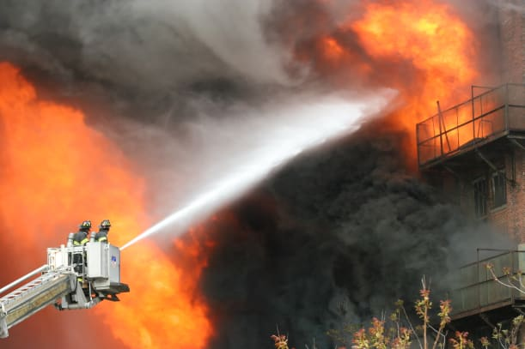 | The ______________ stretches high, so that the firefighter can point the _________ at the flames. A fire truck’s ladder can be raised as high as about eight storeys. The ________ (long metal arm) on the largest fire trucks can extend 4 metres.
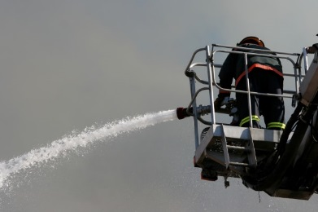 | The firefighter stands in a safety ___________.
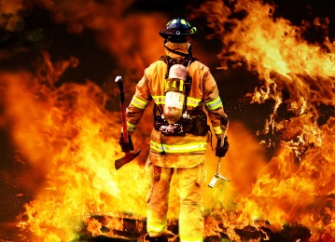 | Fireproof ___________ keep the firefighter safe from the scorching heat and flames.

