Farmer
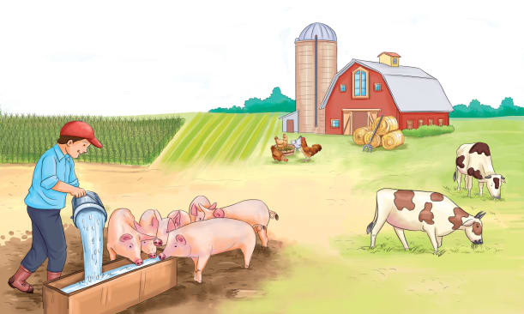 | A farmer is a person who grows __________ (plants) or raises animals for food on a farm. Farmers grow nearly all of the _______ that we eat. Farmers and farmworkers spend a lot of time working outdoors. The ____________ is a big part of having a good or poor harvest.
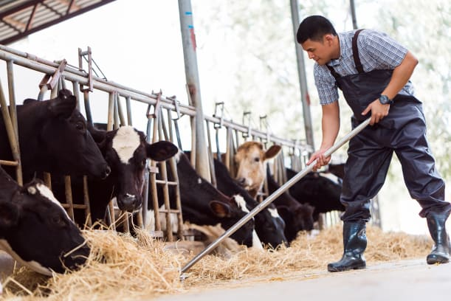 | Farmers feed and take care of _________________ (farm animals).
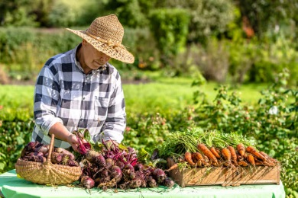 | Farmers plant crops and ___________ (pick) them when they are ready.
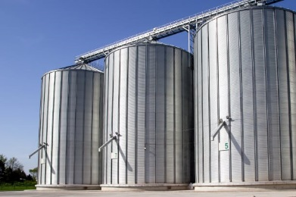 | Harvested _________ and other things for farm animals to eat are kept in a building called a _________.
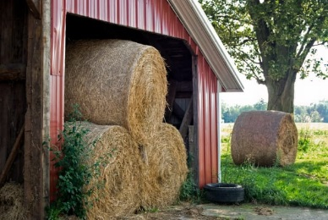 | ________ for livestock to eat is kept dry in a ________.
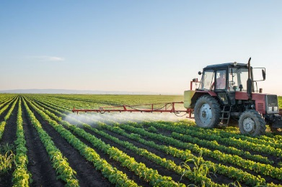 | Farmworkers run many kinds of farm machines. _____________ are one of the most important machines on most farms.

