Excavator
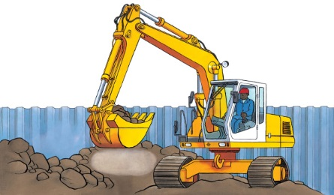 | An excavator picks up ________ and digs big holes. It’s like a giant bucket and __________. It scoops up dirt and moves it from one place to another.
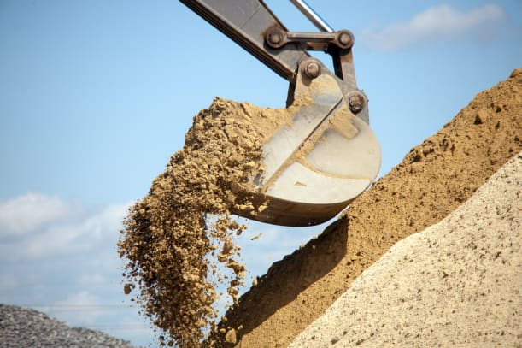 | A large, heavy pile of soil and ________ can be scooped into the bucket.
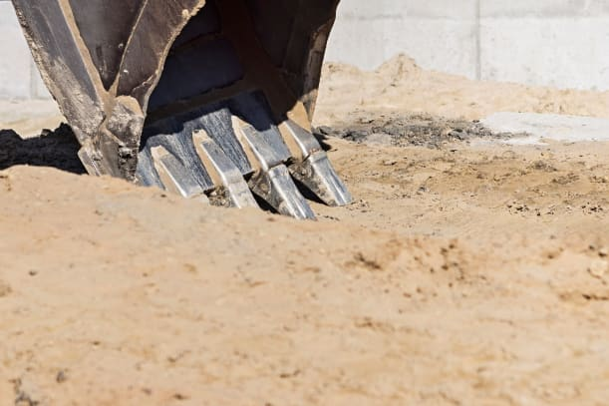 | The bucket’s metal _________ cut into the rocky ground.
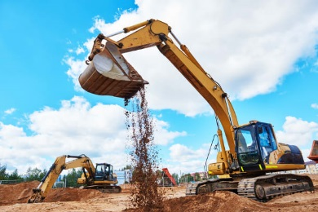 | A long metal ______ moves the bucket to where the driver wants to dig. The arm bends just like your arm does.
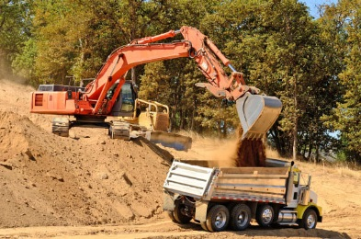 | This excavator is emptying its ___________ into a dump truck.
 | The driver pulls a _________ to lift the bucket.

