Engineers
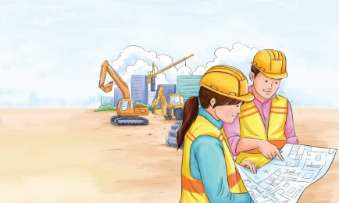 | Civil engineers make plans for _____________, dams, bridges, highways, and railroads. Some civil engineers make plans for ___________, pipelines, and water supply systems. Others study soil and ________ so buildings are put in the safest spots. Civil engineers usually work in offices or at __________________ sites. They tell the workers how to follow the ________.
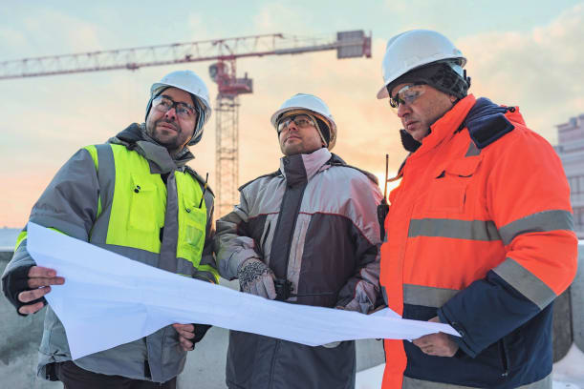 | A civil engineer reads a _____________, a drawing that shows to put up a building. A civil engineer wears a ______________ to protect his head at a construction site – the spot where the building is going up. Backhoes, ____________, and other big machines help do the work on a civil engineering project.
 | American civil engineer John Augustus Roebling was a pioneer in _____________ building. He designed the Brooklyn Bridge in New York city, New York. It was built in ___________.
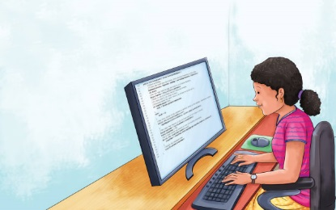 | Software engineers write the instructions (rules) that __________________ follow. These instructions are called a ____________. The programme tells a computer _______ to do and _______ to do it. Software programmes help people to do different kinds of work on the computer. Software works together with _________________, the parts of a computer you can touch.
 | A software engineer uses a computer to create electronic _____________________. A computer’s hardware includes a _____________ and screen. A software engineer writes a programme in a _________ (computer language).
 | Some software engineers create _________ that can be played on a computer.

