Cycads
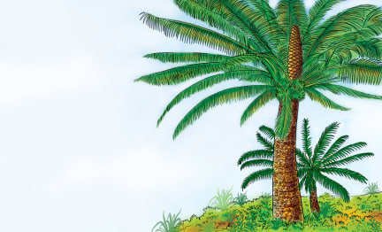 | Cycads are big plants that look much like large __________ trees. Their leaves look like ________ leaves. But cycads are not palm trees or ferns. Instead, cycads are related to other trees that make ____________. There are many kinds of cycads, but they live only in a few damp, ___________ parts of the world. Cycads may live up to _____________ years old.
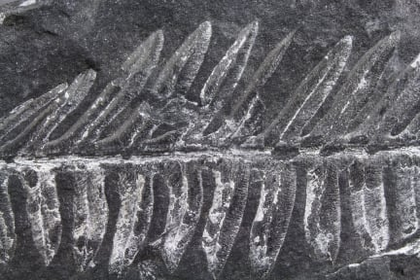 | Scientists have found ________________ which show that cycads lived during prehistoric times. A fossil is the remains of a living that ____________ long ago.
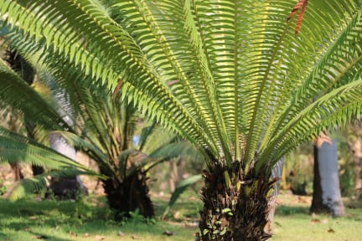 | The cycad has a crown of long, tough _______________. They look like ___________ leaves. The leaves grow in a _____________.
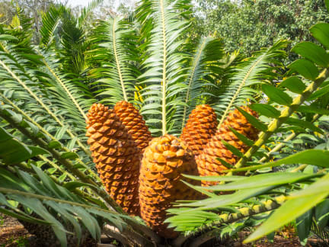 | One kind of cycad is known for its bright _________ cones. They look like large pine cones. They grow in the centre of the circle of leaves and hold the cycad’s ______________.
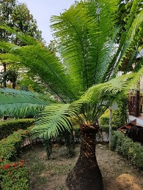 | Some cycads have a thick ________________ without branches. The trunk is covered in rough __________ and stands straight up.

