Crocodile
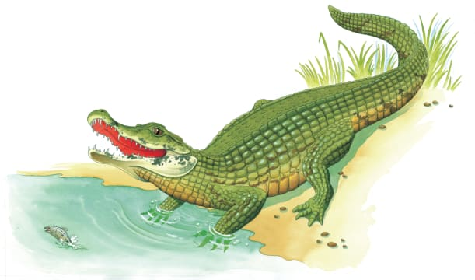 | A crocodile spends the day lying lazily in the warm ________________. In the evening, it floats silently in a cool river, keeping its _________ just above the water, on the lookout for its next meal.
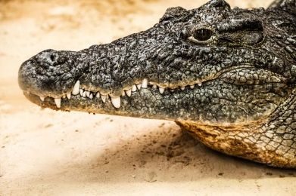 | A crocodile has a narrow, pointed __________ filled with sharp ___________. Some teeth grow extra long and stick out even when the croc’s ________ are closed.
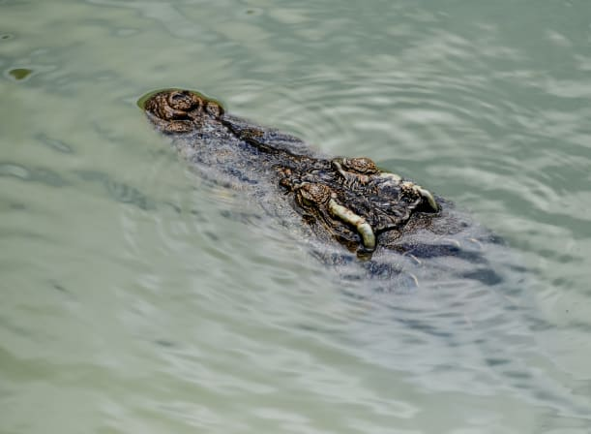 | A crocodile’s eyes and __________ are on the top of its _________. This allows the crocodile to see and _____________ while hiding under water.
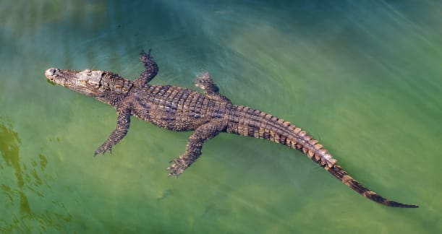 | A crocodile has a long, powerful __________. It ________ by swishing its tail from side to side.
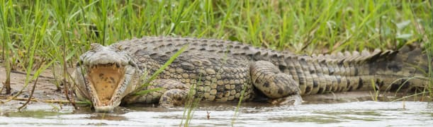 | A tough ________ covers a crocodile’s long, low _________. Crocodiles are sometimes hunted for their hides to make ________ and purses.
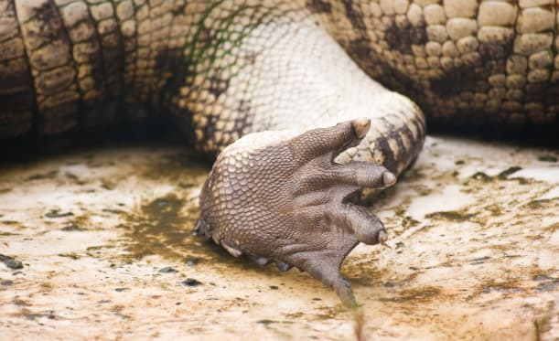 | A crocodile ________________ along the ground on short, stocky _______. Its webbed ________ make it easier to swim and walk on soft, ___________ ground.

