Crane
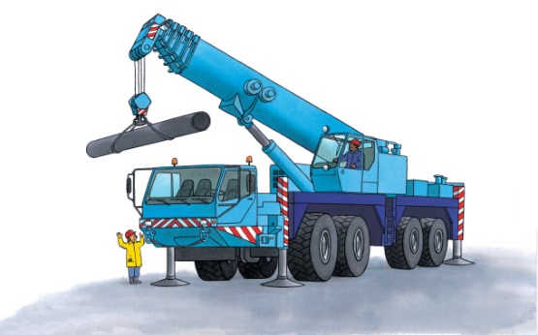 | A crane lifts a heavy _________ high above your head. The crane can turn and __________ and put an object in a different place. It can put a _________ into a deep hole or on top of a tall building!
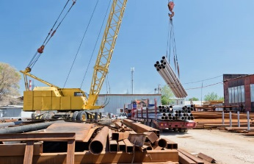 | A crane lifts big pipes that are hanging from ___________. A pipe is a heavy load. A hook grips the wires firmly.
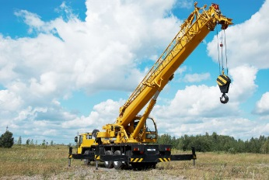 | A crane’s arm is called a ________. The boom can move up and ________ and from side to side, and it can stretch near or _______.
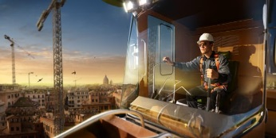 | A crane ___________ works the boom.
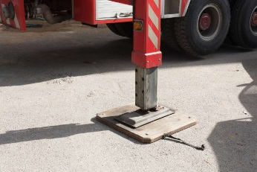 | Giant feet, called _________, stop the crane from toppling over.
 | Tall cranes stand in a line at this busy port. They lift big __________ onto and off of ships.

