Colourful Birds
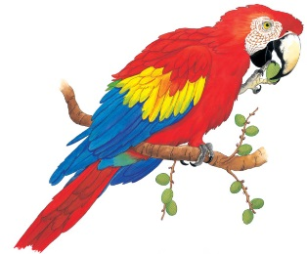 | High up in the leafy trees, rainbow-coloured _______ sing and squawk. They swoop and climb through the trees looking for _____________ and nuts. You may even spot a ____________, one of the biggest birds in the rain forest, munching a tasty treat.
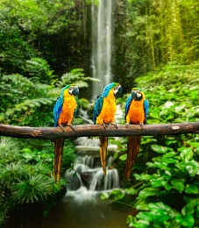 | A macaw’s waterproof _________________ act like a raincoat. They keep out the pouring ________.
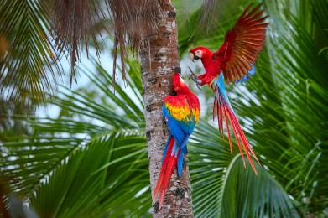 | Macaws have colourful feathers. The feathers may be _______, red, yellow, and _________. These colours help macaws ________ each other among the leaves.
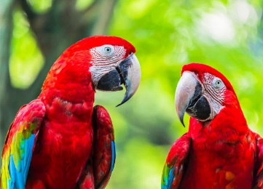 | A macaw has a powerful, hooked _________. A strong beak is perfect for cracking open hard ________ to eat.
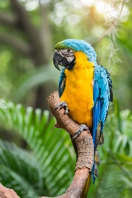 | The macaw has sharp ___________. The claws help a macaw ________ tree branches or hold nuts. These curly claws are called ___________.
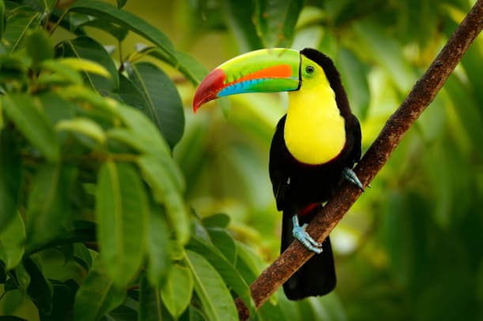 | A toucan’s giant _________ looks heavy. But it is hollow and light. It’s made from the same material as your ___________________.

