Chef
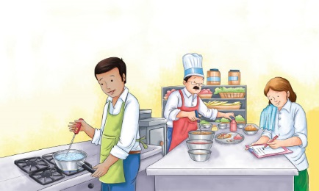 | Chefs work with food almost all day! Chefs are head __________. They work in _____________________, hotels, cafeterias, and in homes. Chefs tell cooks and other kitchen workers what to do. They write __________ and plan __________. Chefs also help prepare and cook the food.
 | Some chefs wear a tall white hat called a __________. An _________ or special coat protects a chef’s clothing from food _____________ and spills.
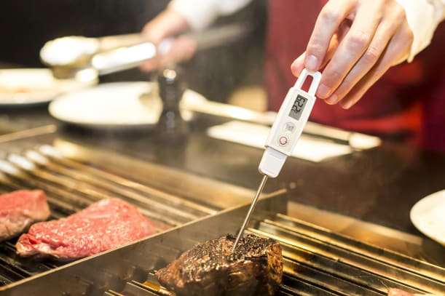 | A chef uses a ______________________ to make sure food is the right temperature to serve.
 | A chef helps plan the _________. A menu is a list of foods in a __________.
 | Chefs ___________ food with great care. They make each dish look ________________.
Do you like to cook? What dishes to you make? | ______________________________________  ______________________________________  ______________________________________

