Cement Mixer
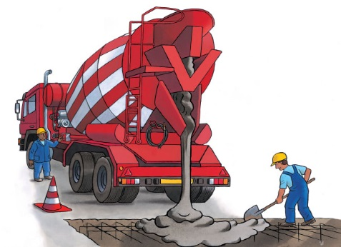 | A cement mixer delivers thick, wet ________________ to a construction site. Inside the big drum, cement and other ingredients are __________ together to make concrete. The concrete is ____________. After a while, it becomes hard and strong. Concrete is used to make walls, floors, roofs, and even ___________ and highways.
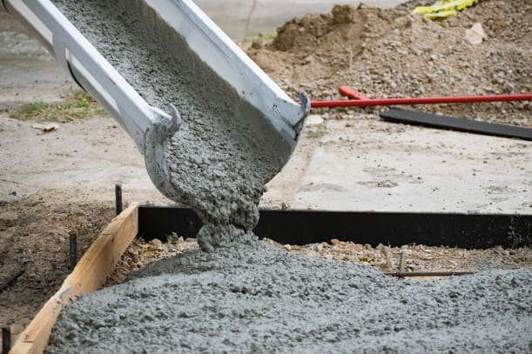 | The wet concrete slides down a ____________ to the ground.
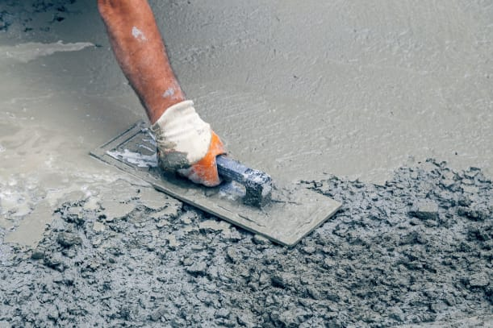 | A construction worker ____________ the concrete. Soon, it will dry as hard as a rock!
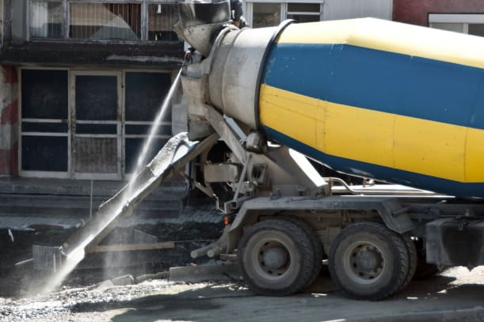 | The ________ turns slowly to mix the sand, water, crushed _________, and powdery cement. The drums of some cement mixers are big enough to hold a car!
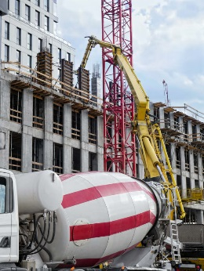 | This _________ pumps its concrete high up to help finish constructing a new high-rise building.

