Car
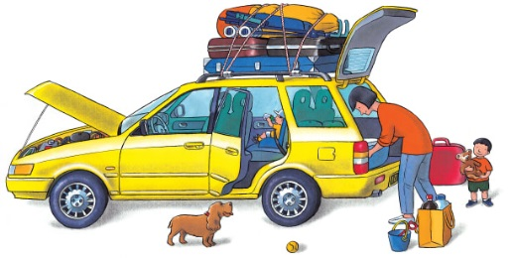 | All over the world, people travel by ______. A car can hold a whole family, and it can go wherever there are _________. Cars are quick, too, but watch out – there may be a traffic jam ahead!
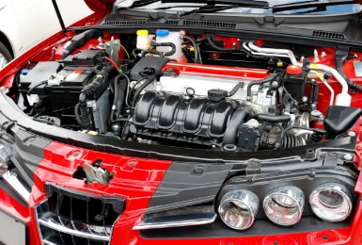 | An ___________ uses ________ to make the car move.
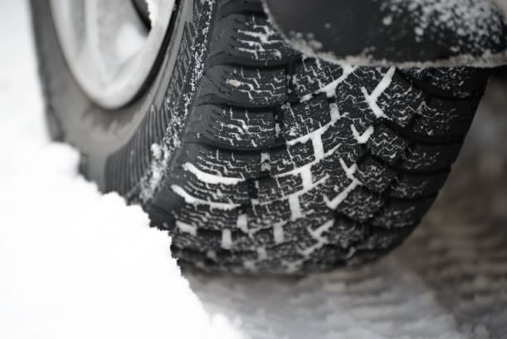 | Thick _________ grip the road, even in wet weather.
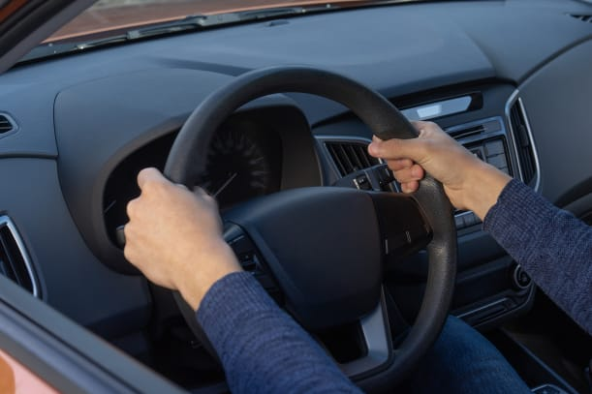 | Turning the _____________ wheel makes the car turn left or __________.
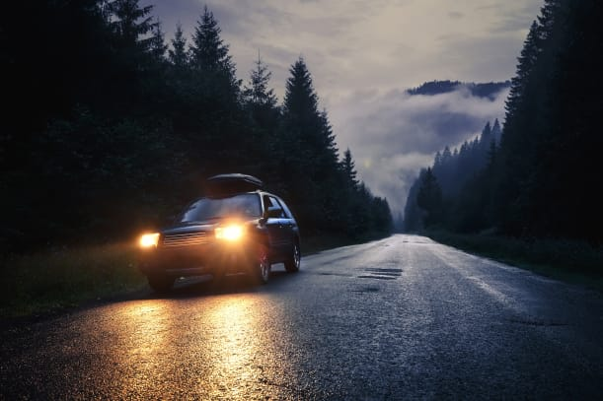 | At night, the car’s bright ________________ light up the road.
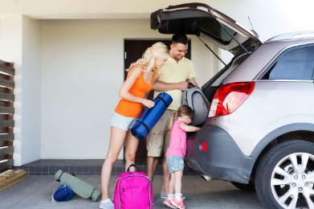 | Everybody helps load _______________ into the boot for the journey.

