Bus
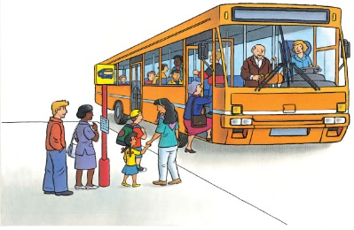 | Buses pick people up and drop the m of at bus ________ all over town. There is room for lots of ____________ inside. As you ride a bus, you can look out the windows and watch for your stop.
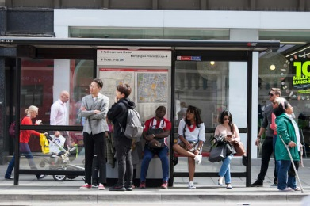 | You wait for a bus at a bus ________.
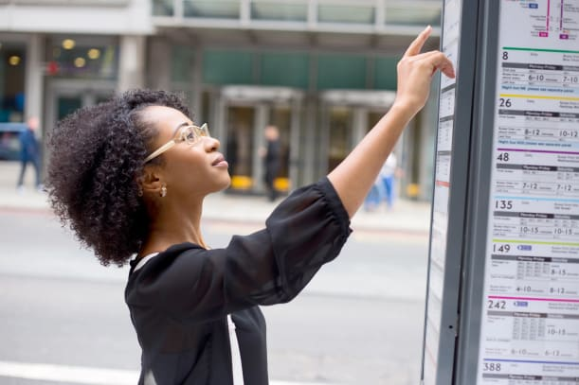 | You read the _____________ to find out when your bus will arrive.
 | The ___________ open to let everybody climb on board.
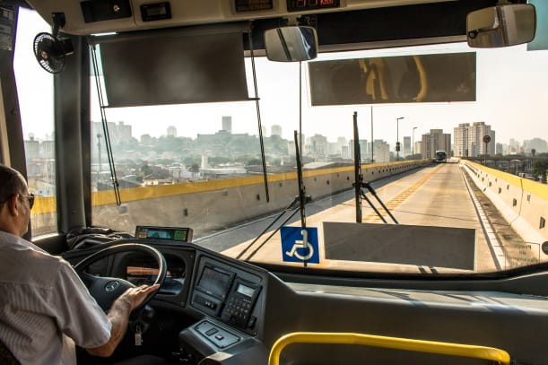 | The driver can see the _______ clearly through the big front _______________.
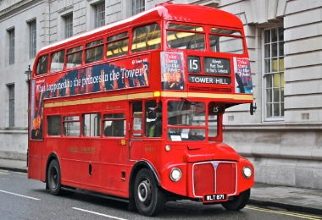 | A _______________-________________ bus chugs through the city. You can sit down below or climb ______________ to the seats on top. A _______ on the front tells you where the bus is going.

