Bus Driver
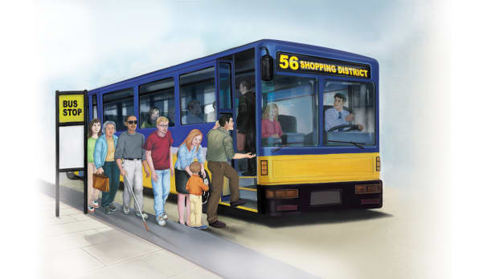 | Bus drivers help people in a community get from _______ to place. Some bus drivers help us get to ____________. Others drive on certain __________ (paths) around town. Bus drivers must have a special ___________ to drive a bus.
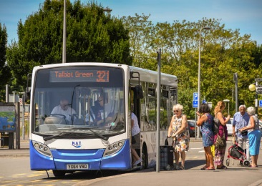 | A bus driver picks up people at a ______ __________.
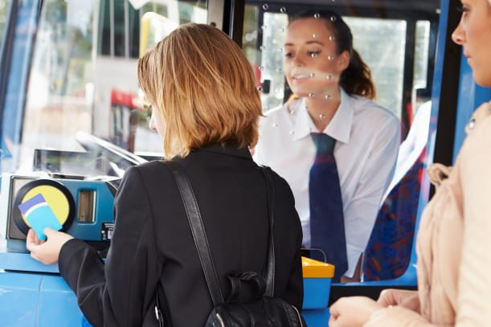 | Passengers _______ to get on the bus. They can use money or a fare ________.
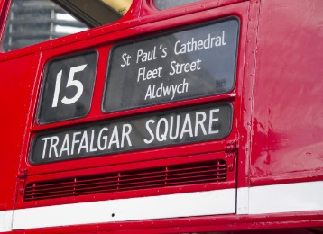 | Buses have numbers that show their _________. The screen on the front of the bus shows the bus’s __________________.
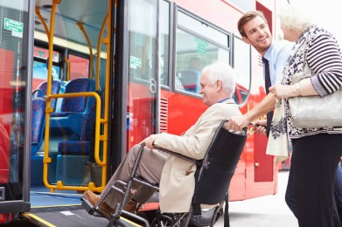 | Bus driver’s help people _______________ the bus.
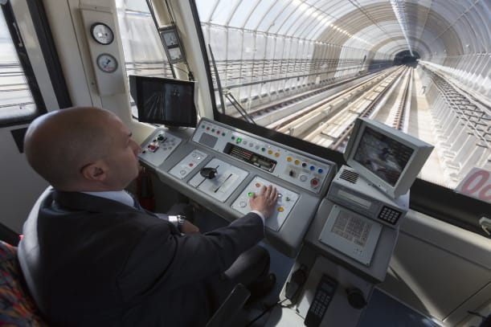 | Many other workers help people get from place to place. Some workers drive __________ that take people into cities.

