Bulldozer
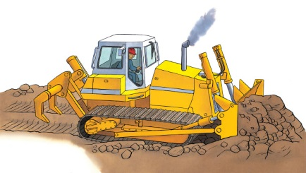 | A bulldozer is the first __________ to arrive at a construction site. This tough truck pushes huge piles of _________ and dirt out of the way. It clears the ground quickly, so people can build new roads and __________.
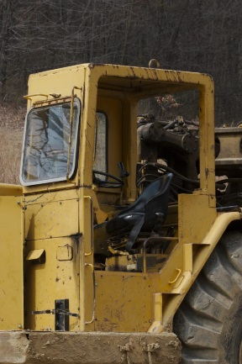 | The ________ has thick windows to protect the driver from the noise of the clattering _____________.
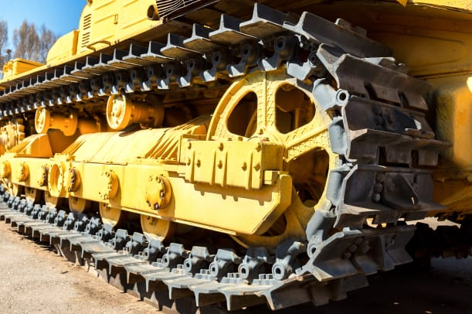 | Caterpillar ___________ roll easily over rocks and soil.
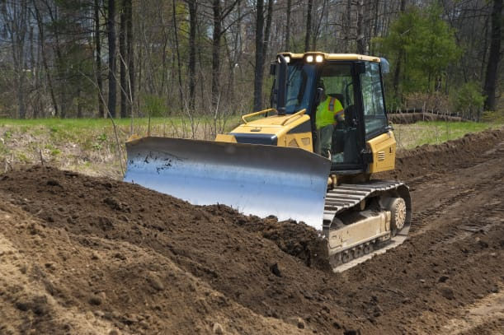 | A metal _________ pushes the heavy piles of rocks and dirt out of the way.
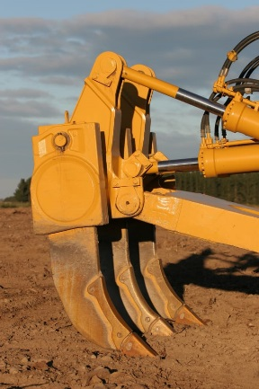 | A bulldozer’s sharp __________ break up hard, rocky ground.

