Bones
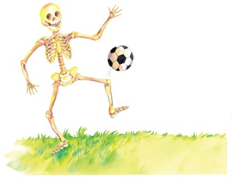 | Inside your body, you have more than _________ hard bones that are different shapes and sizes. Together they make a big, strong frame, called a ____________________.
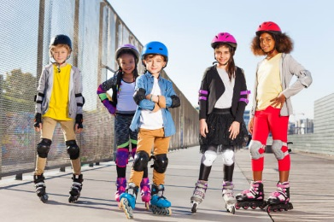 | These skaters are rolling in a park. They wear __________ and _______ to protect their bones if they fall.
 | Luckily, broken bones are easy to __________. A doctor wraps them in a stiff plaster cast, then they _________ together again.
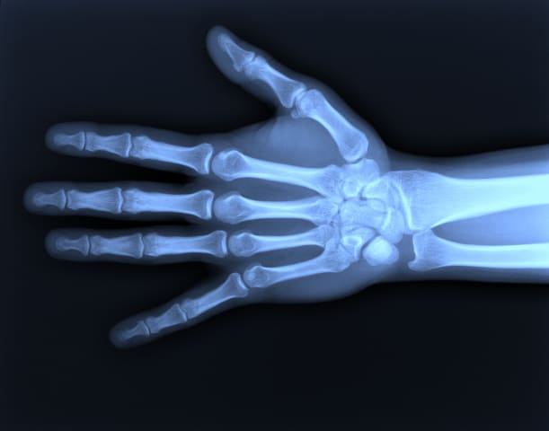 | There are more than _______ bones in the palm, wrist, and ______________ of your hand!
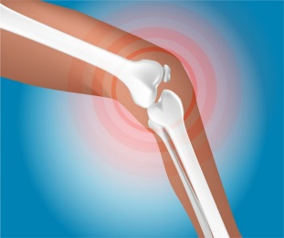 | The longest and strongest bone in your body is your upper ______ bone. Your _______________ protects the joint where your leg bones meet.
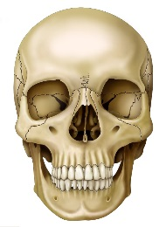 | Your _______ is made up of 14 bones and 32 _____________.

