Bicycle
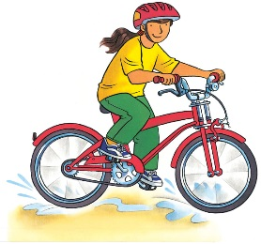 | Bicycles are lots of fun. You can ride to the ________ with your friends or to the stores. It is easy to learn how to _______ a bicycle. You may wobble at first, but soon you will be pedalling like a pro!
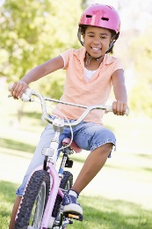 | Always wear a hard __________ to protect your head. Holding the handlebars keeps you steady and lets you ________.
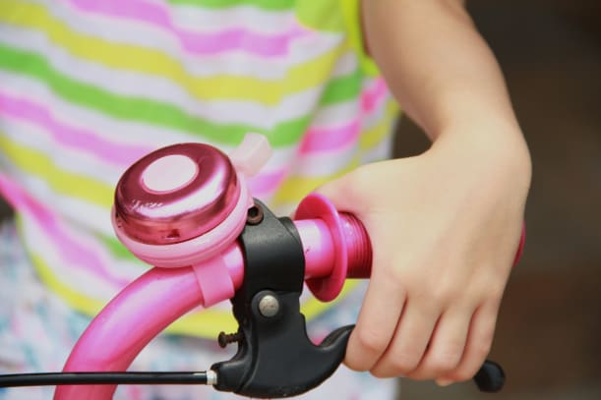 | When you squeeze the ________ on the handlebar, a brake pad rubs against the ___________ to slow you down. You can ring your ________ to warn people that you are coming.
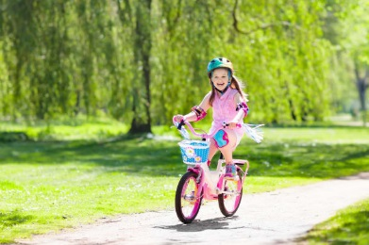 | To ride a bicycle, you sit on the seat and push the __________ with your feet.
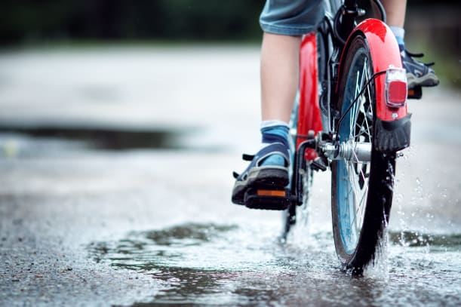 | Two _____________ spin around and move the bicycle forward. A ____________ helps keep you dry when you splash through a puddle.
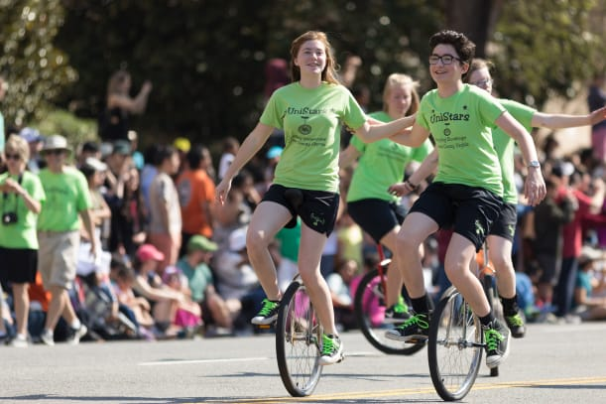 | A _________________ has one wheel and no ____________________. It takes time and a lot of balance to learn how to ride one!

