Bat
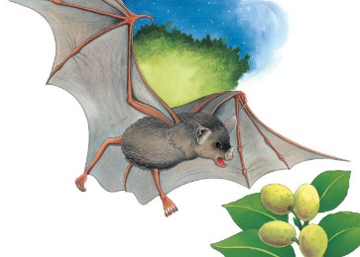 | When night falls, bats _________ up. They stretch their wings and fly off from their daytime resting places in trees and _________. Bats have sharp ________ and eyes to help them find their way around in the __________.
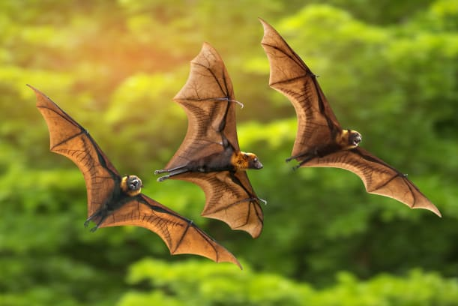 | A bat’s hands are its _________________. Smooth ________ stretches between the bat’s long fingers.
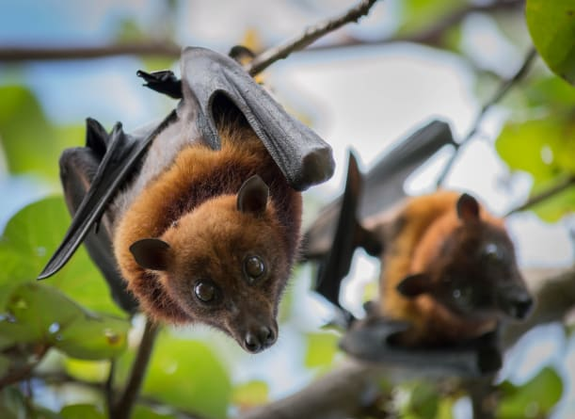 | A bat has a __________ body. It is the only animal with fur that can _________.
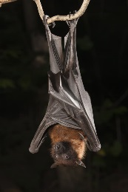 | Bats go to ____________ hanging upside down. They fold their leathery __________ across their furry bodies to stay warm.
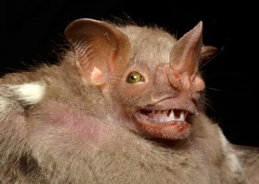 | Some bats have a big leaf-shaped _________. They use this big nose to help find their way around at night!
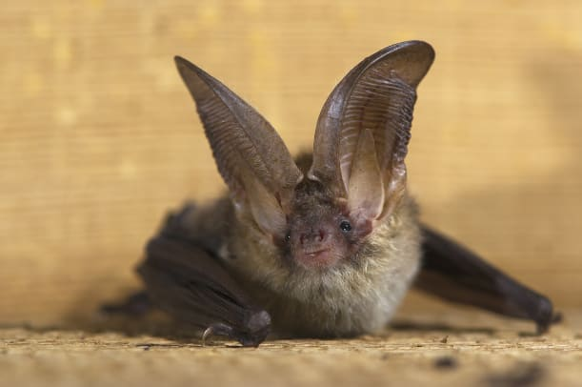 | Some bats have large ________. They can pick up sounds that even you cannot ________.

