Animals Live in Trees
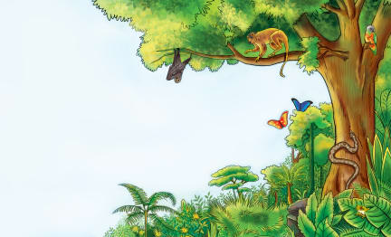 | Trees are _________ for many animals. Monkeys and squirrels live in trees. Birds _________ on tree branches or in holes in trees. Trees may also be home to _______________ and snakes. Look at all these animals that live in trees!
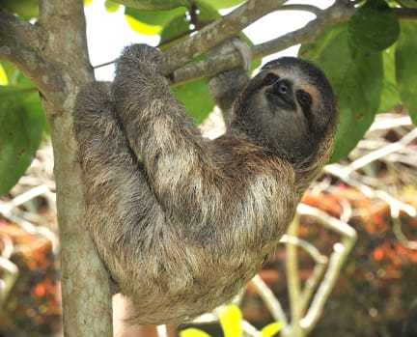 | Many kinds of animals live in the trees of a warm __________ __________________. The ________ is a slow-moving animal of South America. Sloths crawl upside down in trees. They fall ____________ hanging upside down!
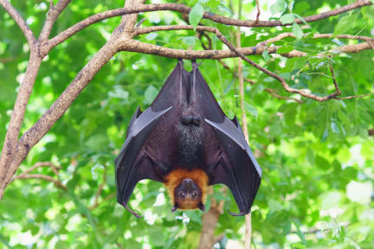 | Many _________ live in trees. They rest by hanging upside down from a tree ________________.
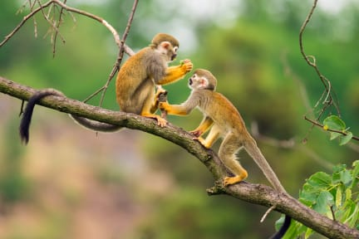 | Many kinds of _______________ live in trees. A monkey can run, jump, or just sit among tree ____________.
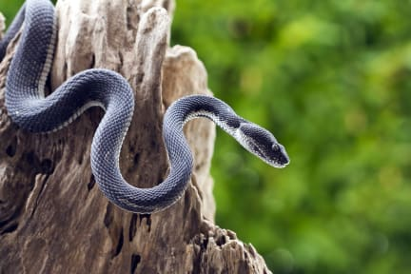 | Some ____________ live in trees. A snake ______________ it’s body as it climbs a tree.
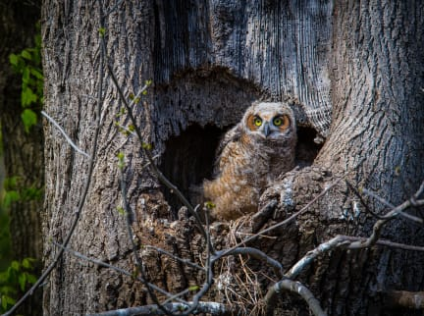 | Some ______________ make their home in a hole in a tree. They build simple _____________.

