Aeroplane
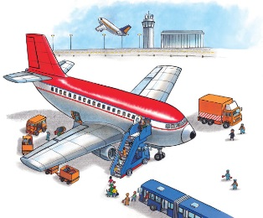 | Aeroplanes take off and land at _____________. They fly high above the _________, carrying people to different cities and countries. In an aeroplane, you can fly across the world in a day!
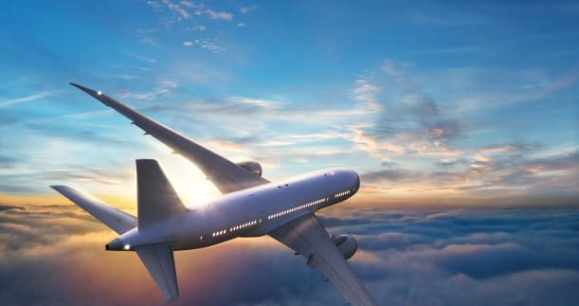 | Huge _________ help the aeroplane soar through the air.
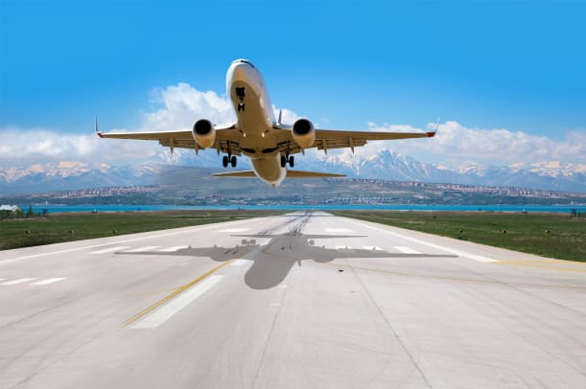 | An aeroplane speeds along the ____________ and takes off.
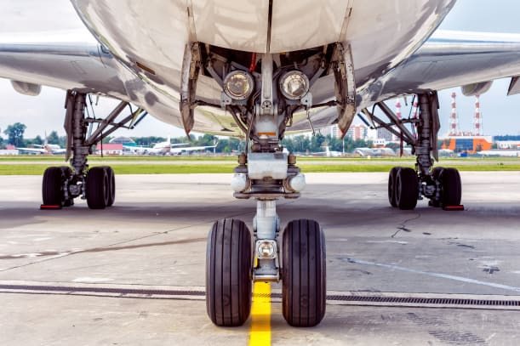 | An aeroplane has strong ___________ to help it land smoothly on the __________________.
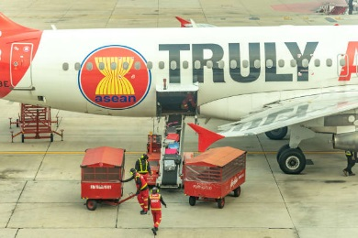 | A baggage truck carries piles of suitcases to the _________.
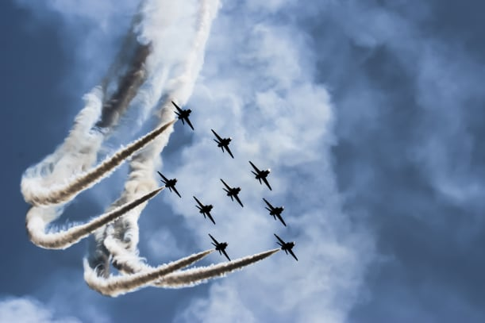 | These aeroplanes take part in an _______ __________. They fly side by side, twisting and turning in the sky.

