Accountants
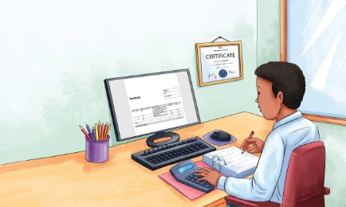 | An accountant is a person who helps people take care of ___________. Accountants help big and small businesses. They help __________, too. They help the people who keep countries, towns, and _________ going. Some accountants work in big companies. Others work in small companies. Some own their own accounting business.
 | An accountant uses a ___________________ to fill out financial forms.
 | A _______________ helps the accountant add up numbers.
 | Some accountants help people fill out forms called income _______ returns. People and companies need to tell the government how much _____________ they make each year.

