Zebra
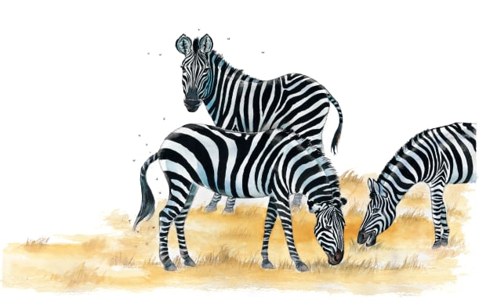 | Zebras are quiet animals that gather in ___________. They wander around, looking for juicy __________ to eat. Zebras are afraid of fierce _________. When they spot a hungry lion, they ___________ off as fast as they can!
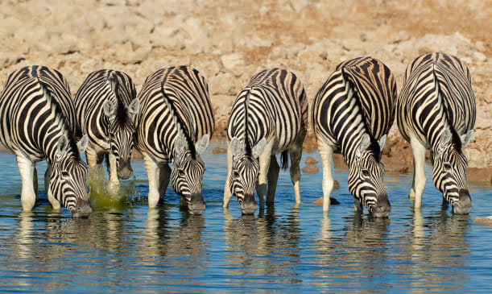 | Groups of zebras may walk for hours across the dry, hot _______________ to drink from a pool of cool water. Look closely and you’ll see that the black and white ___________ on each zebra are different.
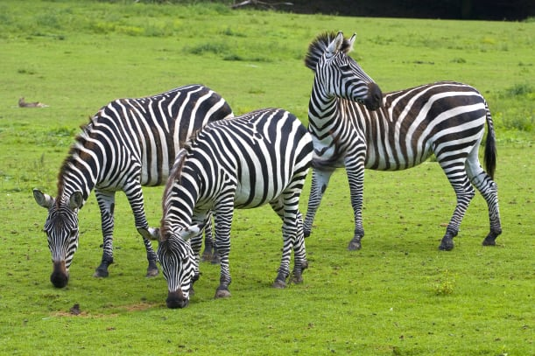 | A zebra’s large ______ move to locate sounds. One zebra listens for danger while the others nibble the grass.
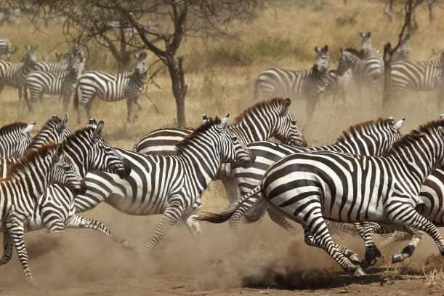 | Zebras _______ quickly to escape danger. They can run as fast as 65 kilometres per hour.
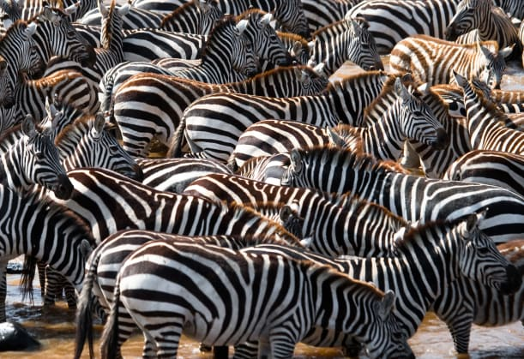 | Zebras live in groups called ________. A herd may have a few zebras or as many as several hundred.

