What is an insect?
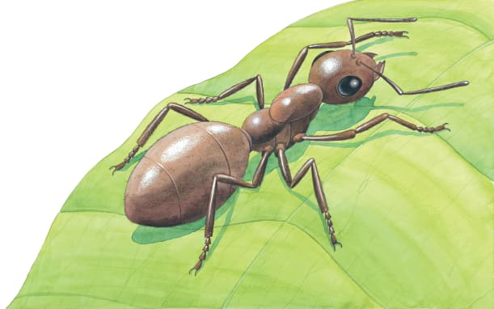 | An insect has ________ main body parts: a head, thorax, and an abdomen. All insects have _____ legs. Many insects also have _______. Insects can be as large as a football or as small as the period at the end of this sentence. The insect shown here is an _______.
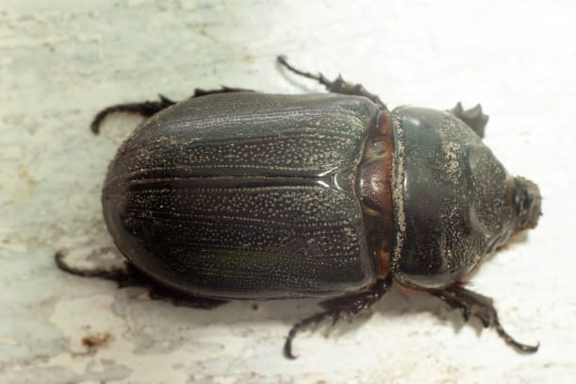 | A tough cover on an insect’s body ____________ its soft insides.
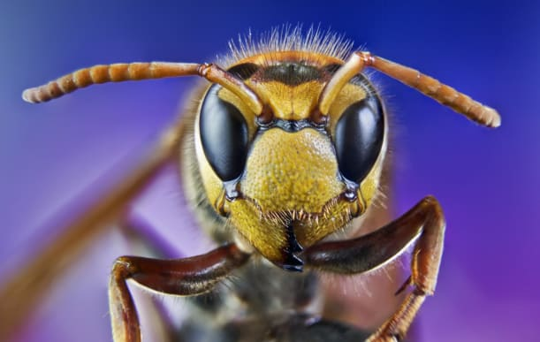 | Most insects have two long _____________. They are used for feeling and _____________. An insect’s head has eyes and antennae, as well as a __________ for eating.
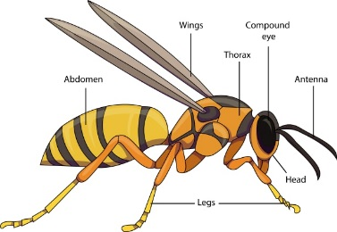 | The middle part of an insect’s body is called the _________. The legs are attached there. They _______________ swells up when the insect eats.
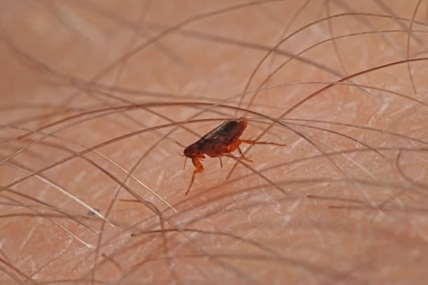 | A tiny flea can _______ 100 times its own height that would be like you leaping over an office building!
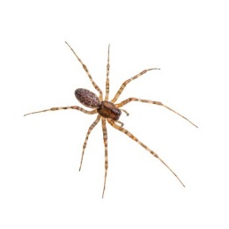 | Spiders are not __________. A spider has __________ legs instead of six, and its body is made up of _______ parts, not three.

