Weird Creatures
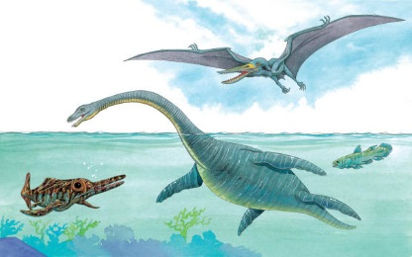 | When dinosaurs ruled the land, the sea was full of unusual creatures. Let’s take a look at some of these amazing ___________!
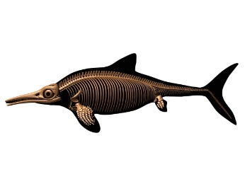 | Opthalmosaurus had huge _______ that helped it spot tasty ________ in the murky water.
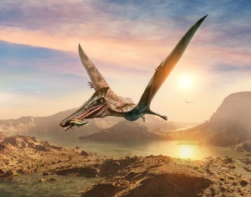 | Fierce Pterodactyls soared in the ______, flapping its huge, leathery ________.
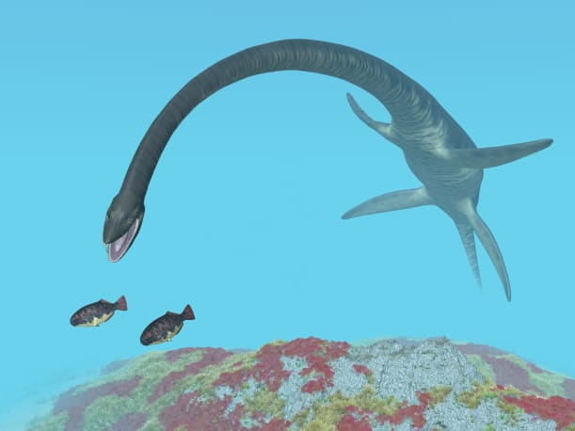 | Elasmosaurus used its strong _____________ to paddle through the water. It stretched out its long ________ to grab other sea creatures for food.
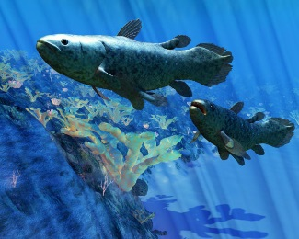 | Coelacanth is a strange-looking ___________. Coelacanths are still living today.
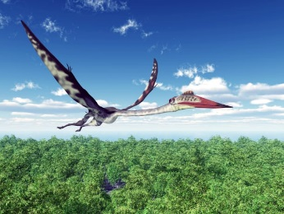 | When gigantic Quetzalcoatlus opened its wings to ______, it was as wide as a small aeroplane.

