Water Insects
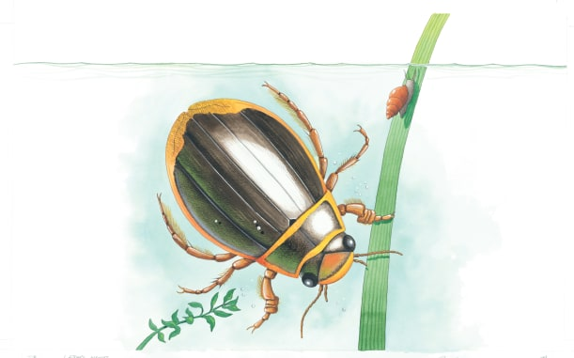 | Many insects live in or near _________. Food is plentiful and there are many places to _______ from enemies. Here, a large diving beetle is plunging deep into the water to look for ________. It carries a bubble of _______ under its wing cases so it can breathe.
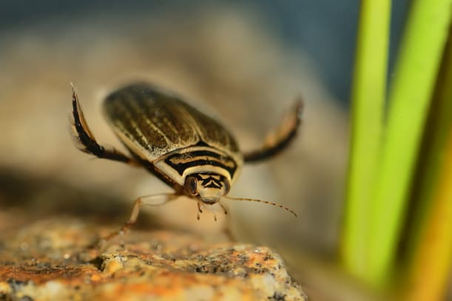 | A flattened _________ helps a diving beetle move quickly through the water. It has hairy back ______ to help it swim and hooks its feet to help hold on to slippery underwater plants.
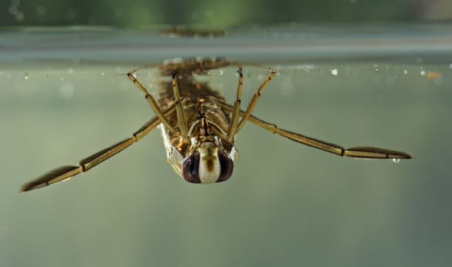 | A backswimmer is an insect that swims ___________ down. It lies on its back and uses its back legs like paddles to move.
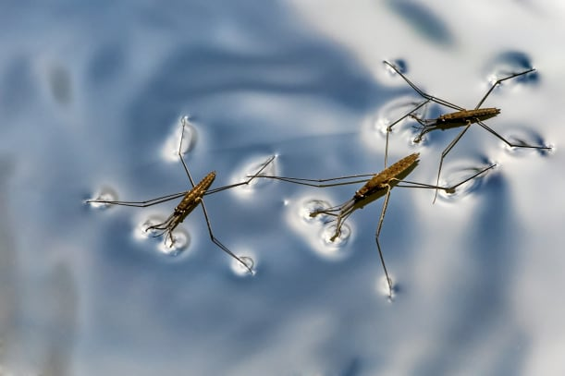 | A water strider can ______ across the surface of water on its long, skinny back legs. It uses its two front legs to grab other insects to _______.
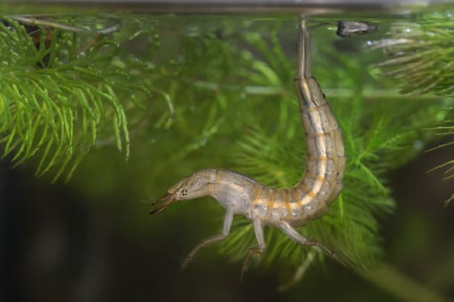 | Baby diving beetles look very different from their parents, but they are just as fierce. They use their big _______ to snap at tadpoles.

