Warm Spring
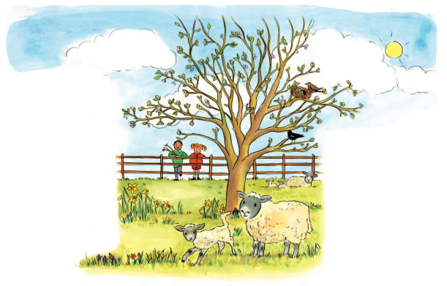 | In ____________, the weather warms up, and the days become ___________. Now that the cold winter is over, plants push out of the ground and new leaves start to ________. Lots of baby animals are born, too.
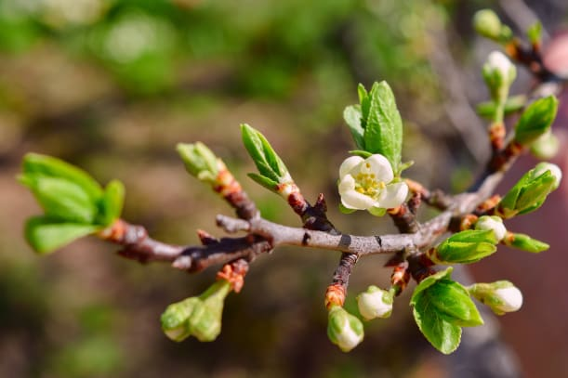 | Spring is a ______________ season. The first _____________ start to bloom. Hundreds of tiny buds start to unfold. The buds become bright green new _____________ and flowers.
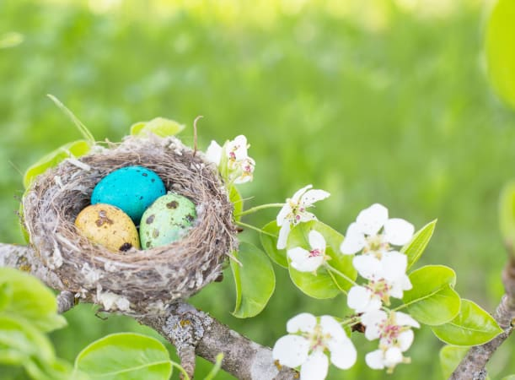 | Birds return from their winter homes far away. They build snug ________. Birds lay _______ in their nests. The eggs will hatch late in the spring.
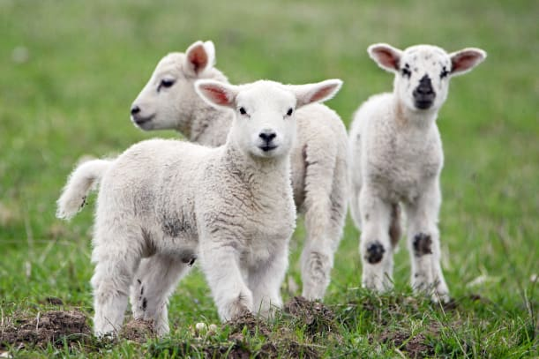 | The spring brings baby animals, like fluffy ducklings, little piglets, and soft baby ________. A baby lamb has a thick woollen coat to keep it warm in cooler days.

