Velociraptor
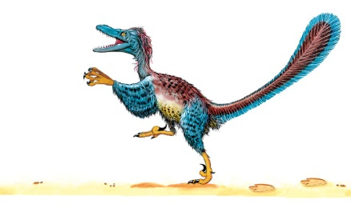 | Velociraptor was a fast runner and an expert ___________. This small dinosaur probably hunted in a group called a _______. Five or six Velociraptors would team up to catch a ___________ dinosaur.
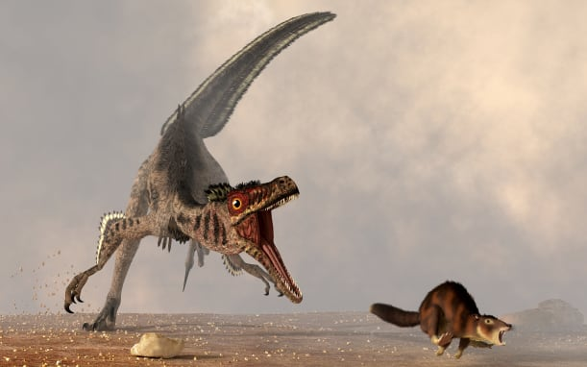 | Velociraptor raced along on its two powerful back _______. It probably used its __________ to catch prey.
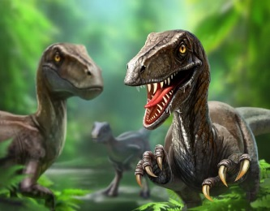 | Velociraptor had strong jaws and sharp _________. These were perfect for grabbing and tearing prey.
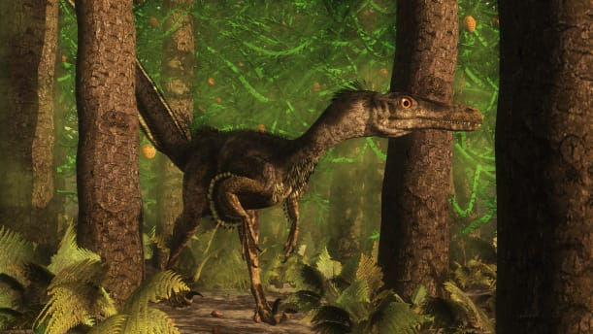 | Velociraptor may have looked like a strange _______. It may have had _____________ covering its body!
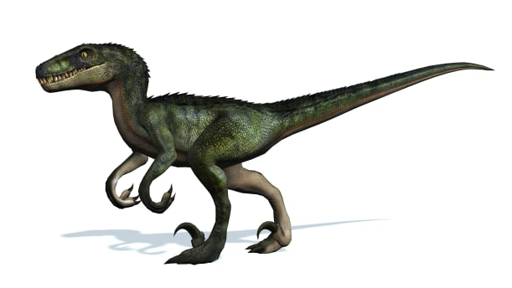 | Velociraptor had a giant ______ claw on its foot. It probably slashed other dinosaurs with these extra-long ________.
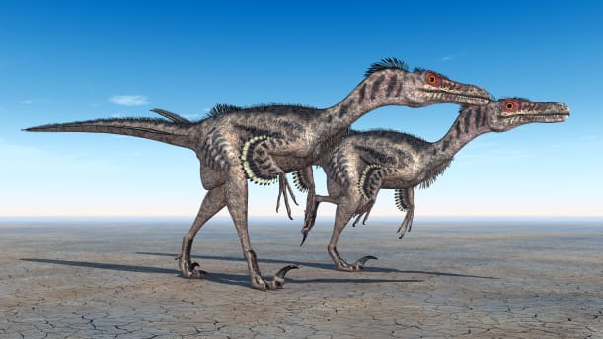 | A stiff ________ helped to keep Velociraptor’s body steady. Its body was about the size of a turkey with a long tail.

