Tyrannosaurus
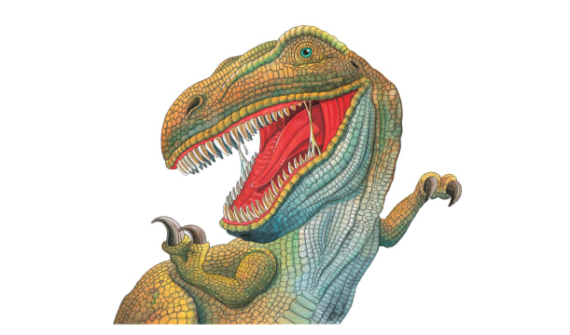 | Mighty Tyrannosaurus was one of the scariest dinosaurs ever! It would sneak up on its dinner, then pounce. Other dinosaurs had little chance against the Tyrannosaurus’s snapping ________ and deadly _________.
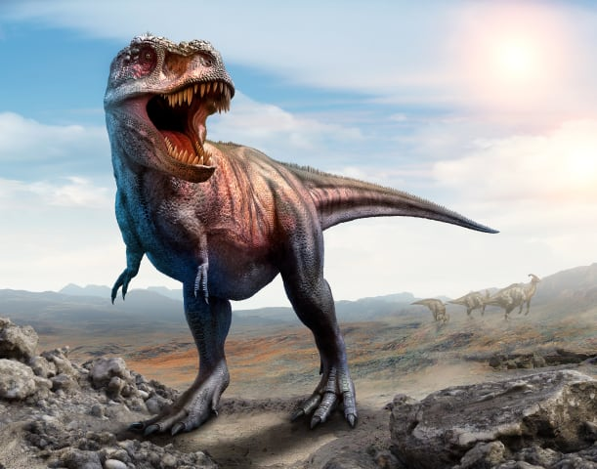 | The enormous curved teeth of Tyrannosaurus were as sharp as ___________. The dinosaur took huge bites of meat with its strong _______.
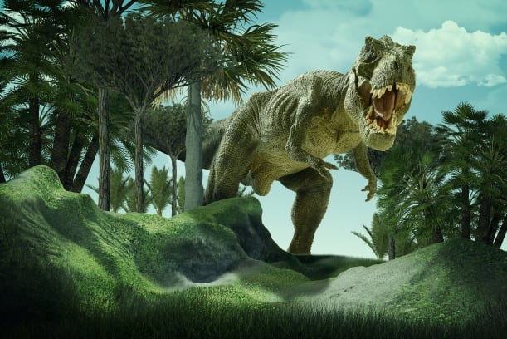 | Tyrannosaurus had a huge ________. A sharp sense of _______ helped Tyrannosaurus to sniff out food.
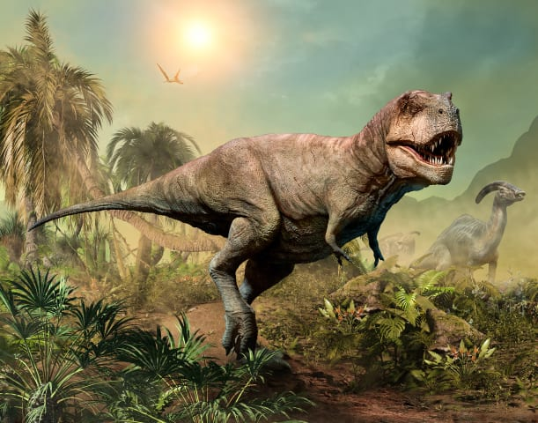 | Tyrannosaurus had two tiny arms. Each arm had two sharp _________ on its small but strong ________. Tyrannosaurus could tear at its victim with these claws.
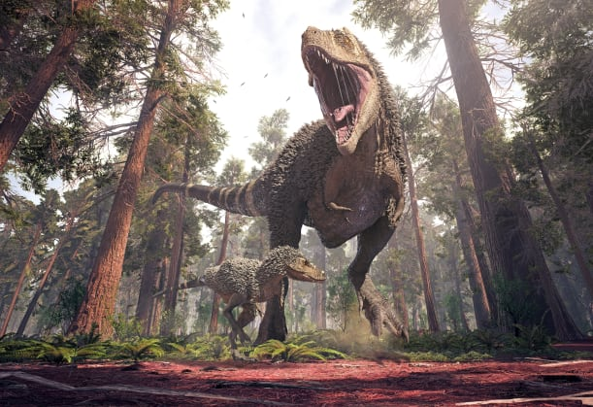 | Tyrannosaurus was the largest _______-eating dinosaur. It hunted _________-eating dinosaurs.

