TRICERATOPS
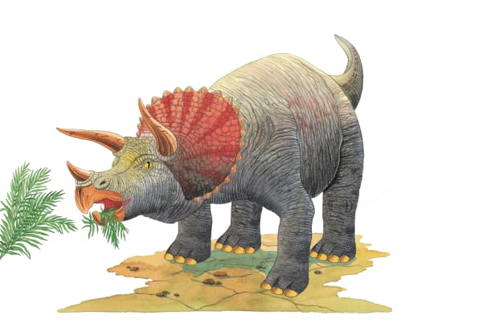 | Triceratops was one of the last dinosaurs to roam Earth. This gigantic beast plodded around, looking for tasty ________ to eat. It probably gathered in large groups called ________.
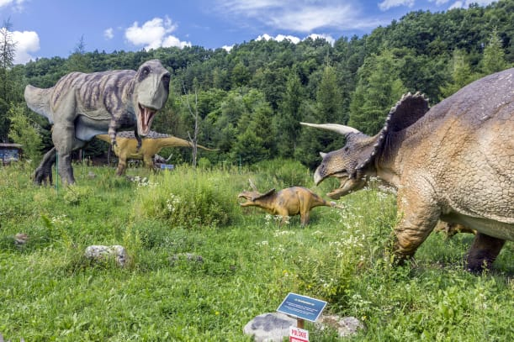 | A bony neck ________ made Triceratops look scary. The frill may have helped Triceratops defend itself against large, meat-eating dinosaurs such as __________________________.
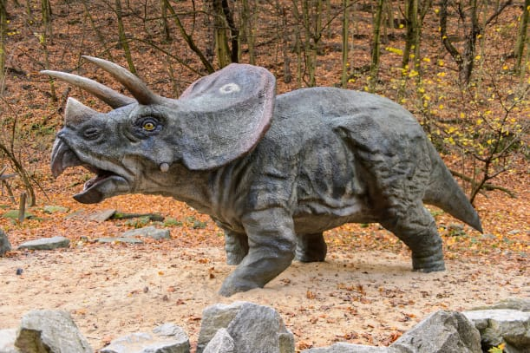 | Triceratops used its three pointed _________ as weapons. There were two long, sharp horns over its ________ and one short horn on its nose.
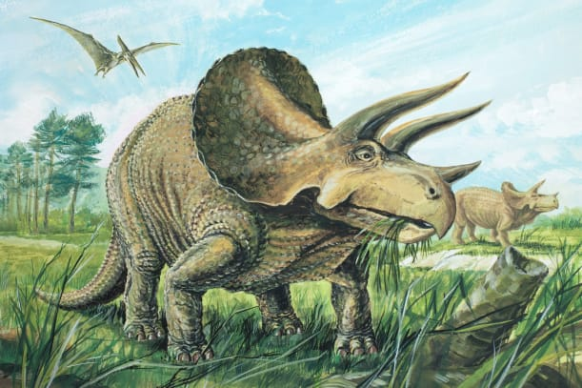 | Triceratops had a huge _________! Its powerful _______ was used to cut tough leaves and twigs to eat.
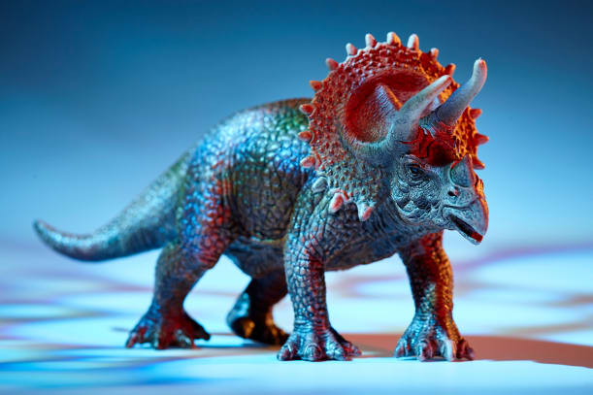 | Triceratops had thick, stumpy _________ and short, fat toes. It also had a short, heavy _________.

