Treehouses
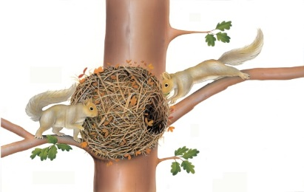 | It’s safe high up in the trees! Hungry predators are far below on the ______________. Squirrels build nests in trees. A noisy woodpecker drills a hole in a thick tree trunk.
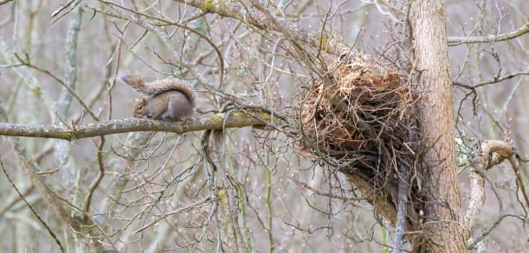 | A squirrel builds a summer _________ on a strong branch. ________ make the nest firm and strong.
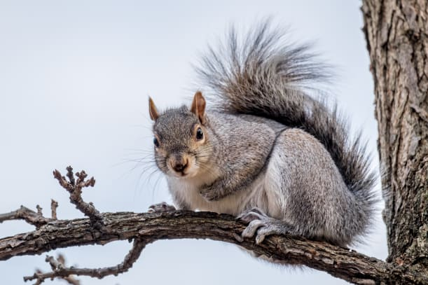 | A squirrel’s bushy _________ helps it keep its balance in the treetops.
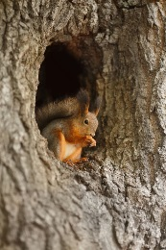 | A squirrel makes a cold-weather nest inside a hollow __________.
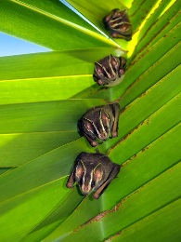 | Tent bats camp out in the trees! The bats fold a ________ into a tent shape. They hide underneath their tent.
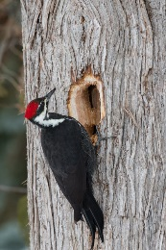 | A woodpecker taps at a tree with its long, sharp _________ for hours. It makes a round ________, where it will live.

