Thunder and Lightning
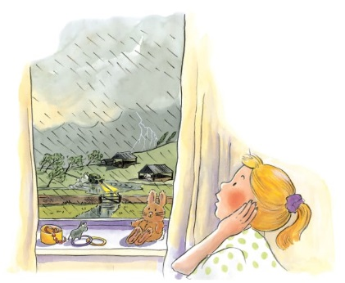 | When clouds in the sky loom big and dark, and the wind starts to howl, you know a _________ is on the way. Suddenly, ________ pours down. A storm can be exciting, but make sure you stay safely inside your home.
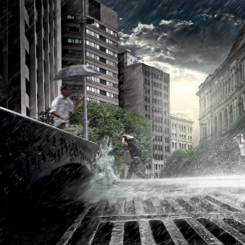 | A huge black __________________ covers the sky. It’s raining so hard that the road has started to __________.
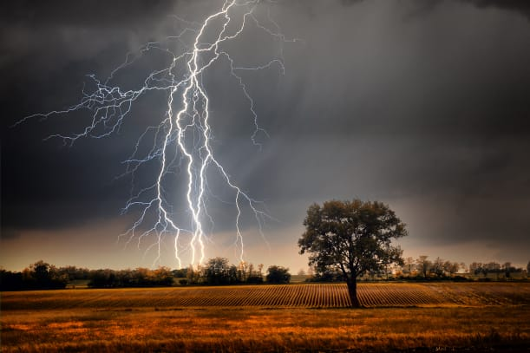 | Dazzling ________________ is a giant spark of electricity from a thundercloud. It lights up the sky for a few seconds. Boom! If you see lightning, you will soon hear ______________.
 | During a storm, lumps of ice, called _________________, may fall from the sky. The largest hailstone ever spotted was almost as big as a soccer ball!

