Stegosaurus
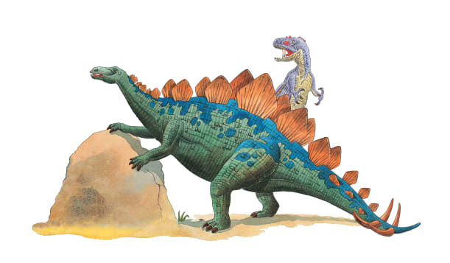 | Stegosaurus spent most of the day munching _________ and twigs. When it wanted to nibble at taller bushes, it stood up on its long back ________. Special _________ grew from Stegosaurus’s body. These might have helped control the dinosaur’s ________________.
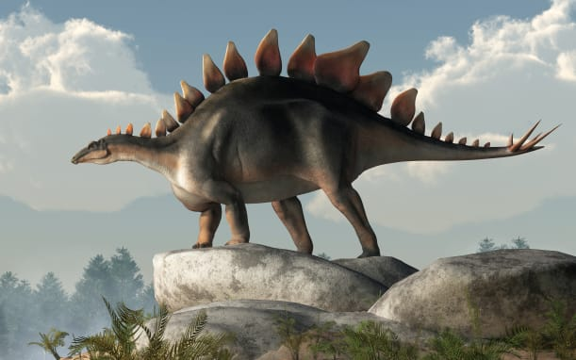 | Stegosaurus had a heavy body and a small _________. It had to eat lots of leaves to fill its large _________. Two rows of bony plates grew along its back and _______.
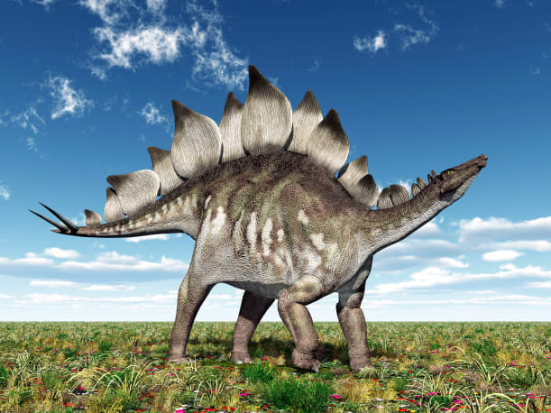 | Stegosaurus had sharp _________ at the end of its tail. It could fight off attackers by swinging its dangerous ________.
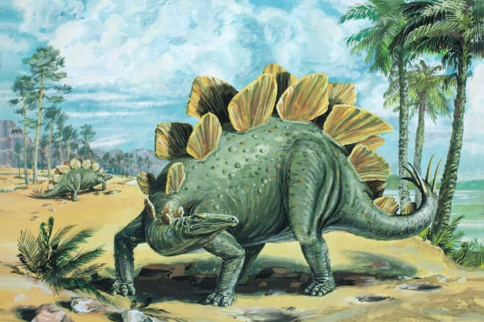 | Two rows of ________ plates grew along Stegosaurus’s back and tail. The bony plates may have helped Stegosaurus warm up and ________ down.

