Snow and Ice
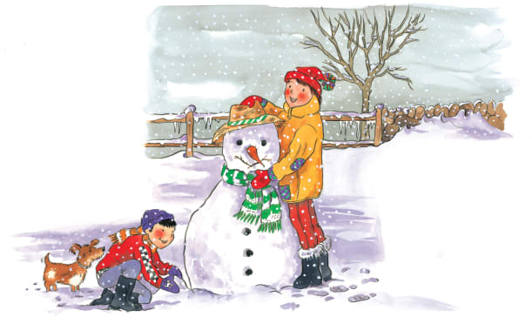 | On a cold day, snow falls from the _______ and covers the ground in a white carpet. You can make funny shapes out of fresh, wet snow. If it’s freezing cold, the snow may turn into hard slippery ______. Long, sharp ________ are frozen drips of water or snow.
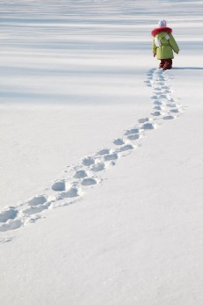 | Water in the clouds freezes into __________________ that fall gently to the ground. The wind blows the snow into a big pile called a ____________. It’s fun to make footprints in the crunchy snow!
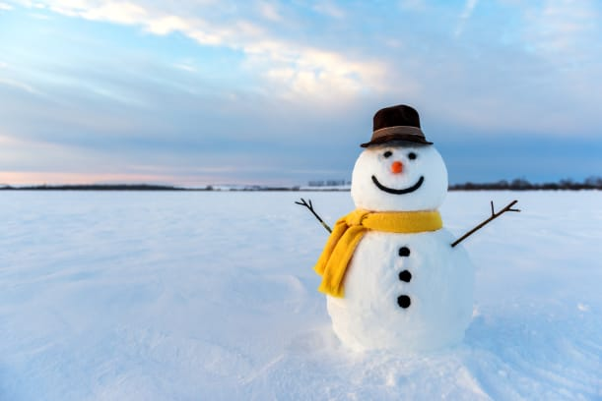 | A smiling __________________ lasts for as long as the weather stays cold.
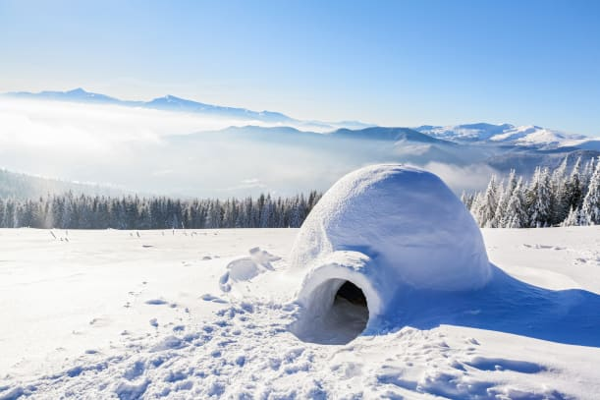 | In some of the coldest parts of the world, people called __________ once built shelters called ____________ out of snow and slabs of ice.
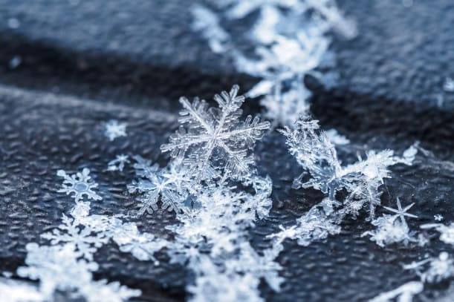 | Every tiny _________ of snow has a different pattern. Look at these delicate, lacy snowflakes.

