Shells
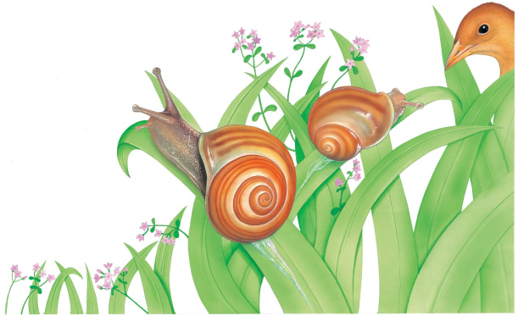 | Some animals carry their ________ around with them, wherever they go! A slimy snail has a __________ on its back, in dry weather, the snail hides inside the shell. But when it’s wet, it pokes out its head in search of tasty __________.
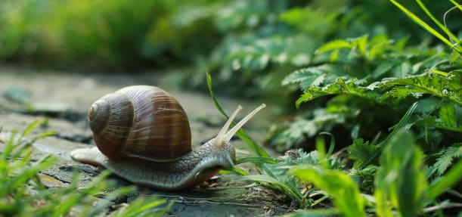 | A snail crawls along, searching for juicy leaves to much. A hard, round shell covers the snail’s soft _________. The shell is the snail’s ___________.
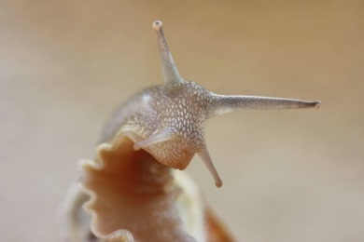 | ______________ help the snail to find its way around.
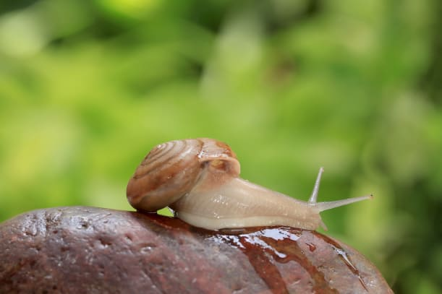 | As a snail crawls along, it leaves a shiny trail of _____________!
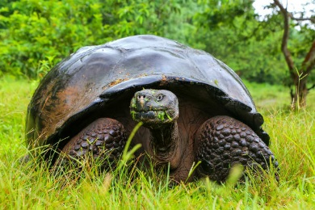 | A tortoise lives inside its tough shell. When the tortoise goes to _____________, it pulls its head into its shell.
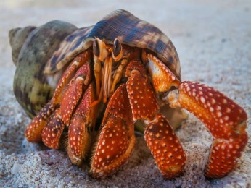 | A hermit __________ doesn’t have its own shell, so it borrows one! When the crab grows too big for the shell, it finds a _______ one.

