Shark
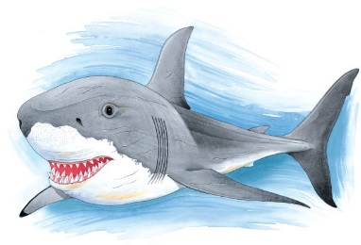 | A hungry shark swims through the water to hunt for its dinner. It can ______, hear, and smell a meal from far away. A few kinds of sharks, like the great white in the picture, are fierce, but most are quite shy.
 | A ______________________ shark looks very odd. It has a wide, flat head like the top of a hammer and an ________ at each end.
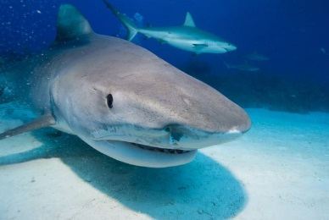 | A ________ shark is like a garbage collector. It eats everything it finds – even empty tin cans and old boots.
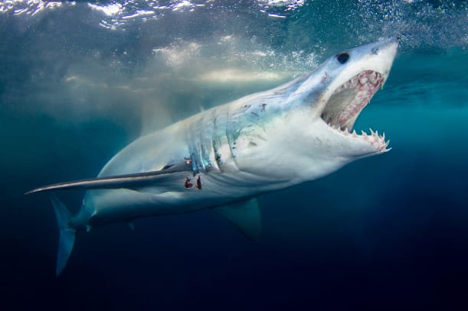 | A shark has rows of razor-sharp __________. When an old tooth breaks or wears out, a ______ one takes its place.
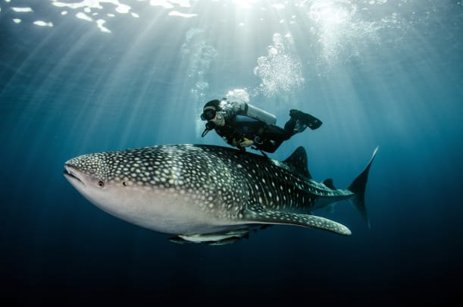 | Some people are afraid of sharks. Some kinds of sharks have attacked and killed people. But such attacks are very ________.
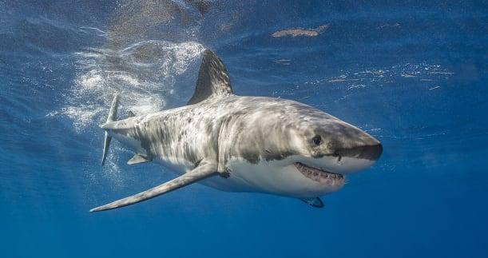 | A shark pushes itself along by beating its _________ from side to side. A stiff _______ makes it easy to turn in to the water.

