Sea Turtle
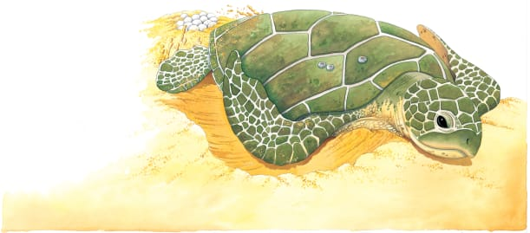 | A sea turtle can live for as long as 100 years! It usually spends its time paddling ___________________ in warm, shallow seas. Every few years, a mother turtle swims to a sandy beach. She crawls up the shore and lays lots of _________, which hatch into baby turtles.
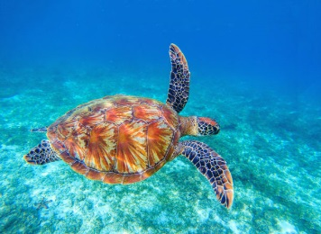 | A sea turtle swims _______. It uses its long front ____________ like oars, as if it is rowing through the water.
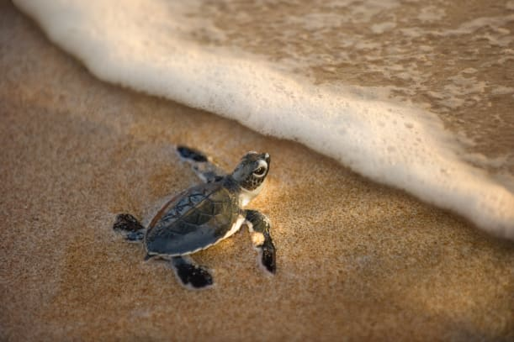 | As soon as baby turtles hatch, they climb out of their sandy hole and crawl to the _______. It’s an adventure!
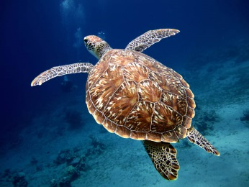 | A thick, heavy __________ protects the turtle’s soft body underneath. Hard, bony scales cover the shell and make it ____________.
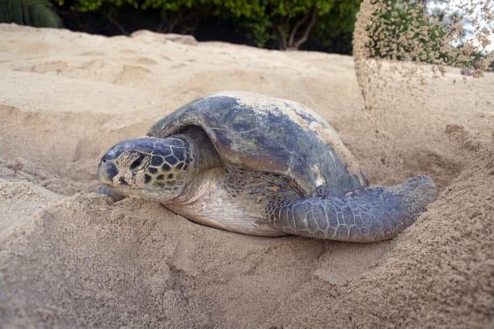 | At night, a mother turtle digs a hole to lay her eggs. She covers the eggs with _________, using her short back ______________.
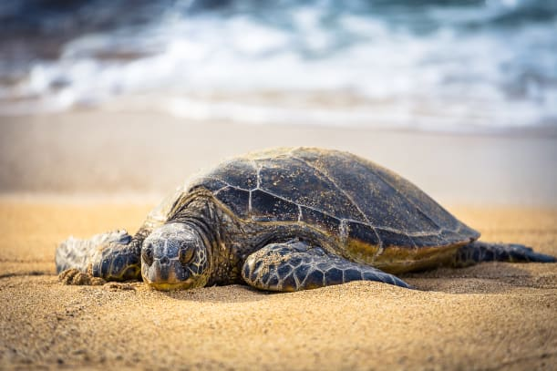 | Huge front _______________ are great in the water. But, they make moving in sand much more difficult.

