Seahorse
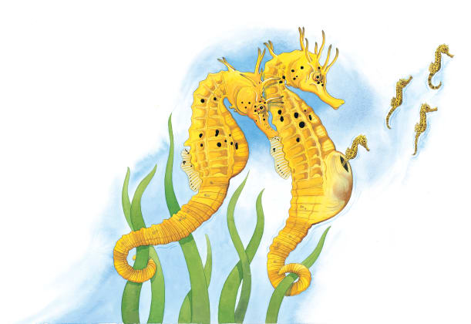 | Seahorses are ______ that like to bob about gently in seaweed. Seahorses have hundreds of babies. A mother seahorse gives her ________ to a father seahorse. He keeps them all in a special ouch until they ____________.
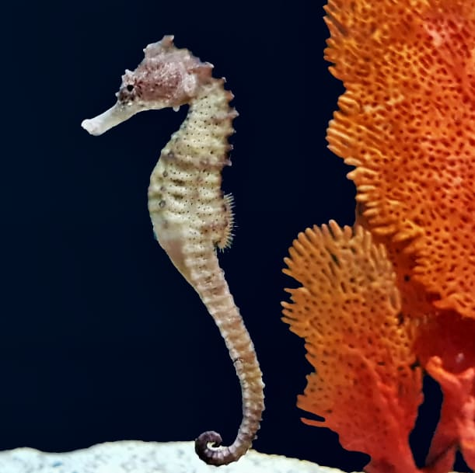 | A seahorse has a _________ that looks like the head of a tiny horse. It sucks up food with its long _________ and swallows it whole.
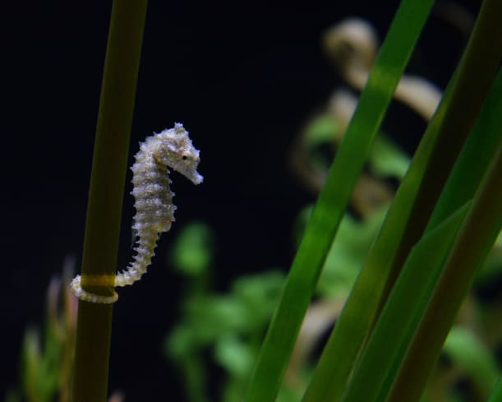 | Some seahorses are very small. The tiniest seahorse is smaller than _________.
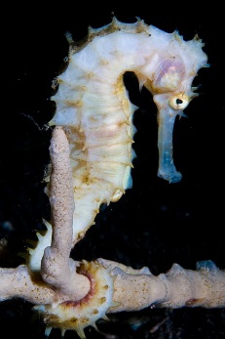 | Seahorses have long, bendable ________. When a seahorse wants to rest, its tail is good for clinging to _________________.
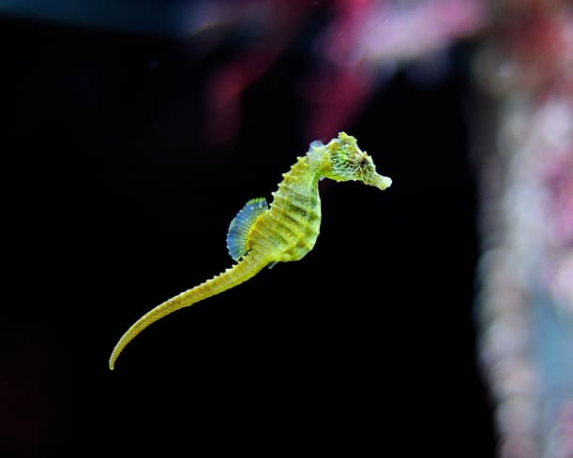 | A seahorse swims by flapping its tiny ________ to and fro.

