Rhinoceros
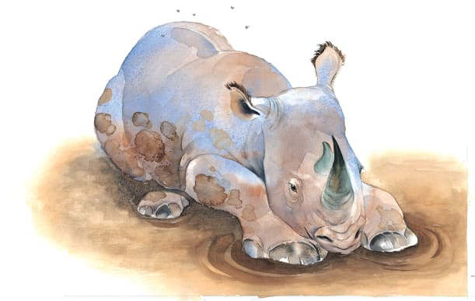 | A rhinoceros, or _________ for short, lives but itself. It spends the day dozing on the grass, nibbling at ___________, and rolling around in wet ______ to cool down. All the other animals keep out of its way because it looks so fierce!
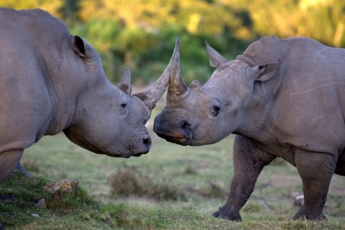 | A rhino’s pointed horn is useful for digging up juicy plants and for ______________. The rhino’s horns keep growing throughout its life.
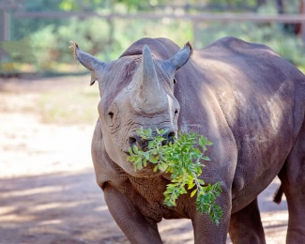 | A rhino pulls twigs from a bush with its long top _______. It chews the twigs with its flat back ____________.
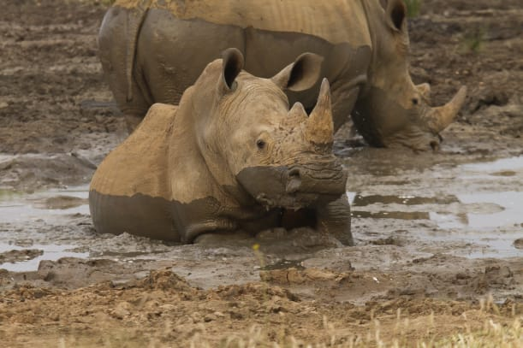 | A coat of _______ stops a rhino’s heavy body from burning under the hot sun. The mud also keeps biting ___________ away.
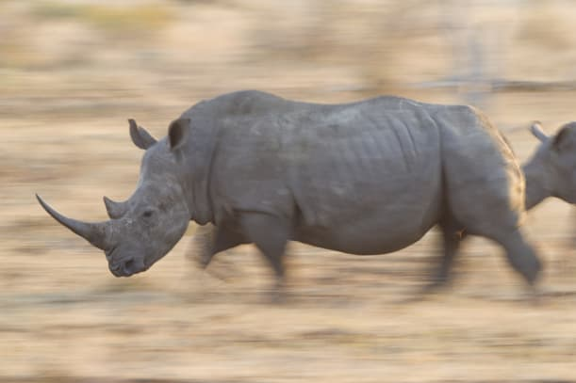 | A rhino has terrible _____________. Sometimes it charges at __________, thinking they are big scary animals.
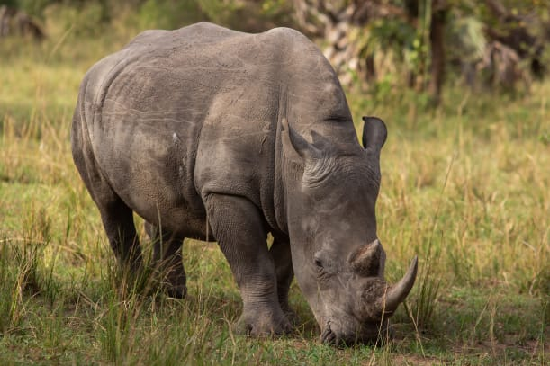 | The rhinoceros is one of the ________________ land animals. Some rhinoceroses are heavier than an automobile.

