Rays
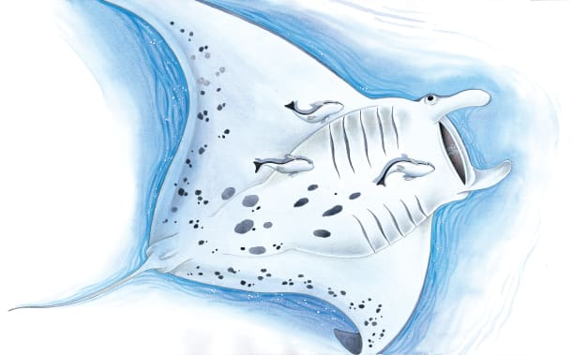 | Some rays lie on the sandy __________. Others swim near the top of the ocean. In the big picture, you can see a __________ ray. Its flat body glides swiftly along like a strange bird. Sometimes it flies right out of the water!
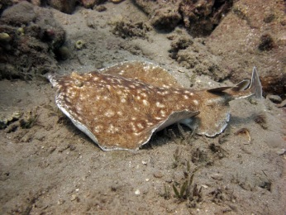 | An electric ray has a special way of catching food and defending itself. It stuns fish with ______________ from its body so they can’t move.
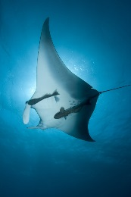 | To move, a manta ray flaps its big ____________ slowly up and down. A manta ray speeds along so quickly that small _______ grab on for an exciting ride!
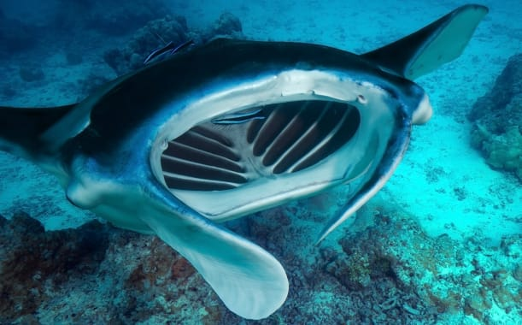 | A manta ray swims with its mouth wide _________ to catch tiny creatures. Two curly flaps guide juicy bits to its mouth.
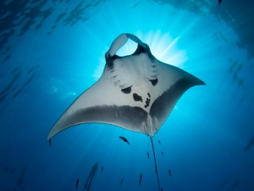 | A manta ray can bend its smooth, wide ___________ and do a loop-the-loop!
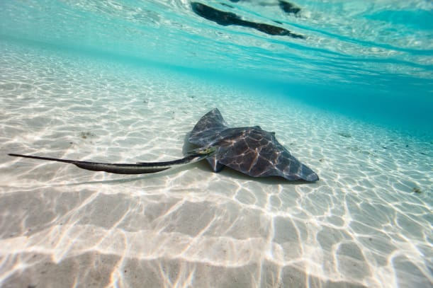 | Most rays ________ on the sea floor. They _________ creatures that live there.

